**Client: Southern States Bank**

**Project Name: File # 240415042**

**State Registration # 127**

**Keystone File # CM037424**

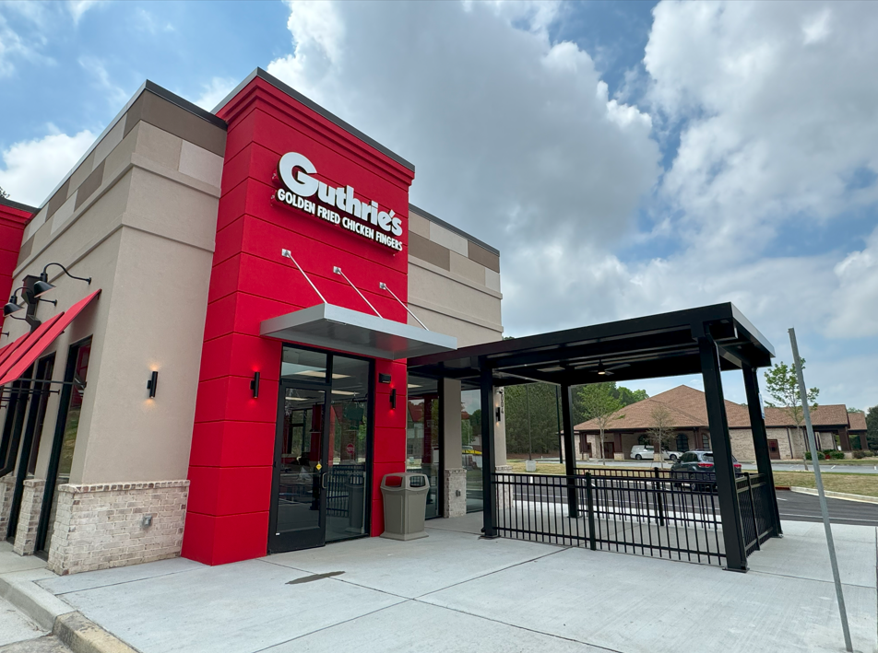

**2,187 Sq. Ft. Restaurant Building**

**On 2.387-Acres**

**2004 Eagle Dr**

**Woodstock, Cherokee County**

**Georgia 30189**



April 24, 2024

Southern States Bank

615 Quintard Ave

Anniston, Alabama, 36202

Client Reference: File # 240415042

Keystone File: CM037424

To Whom It May Concern:

At your request, Keystone Valuations has prepared an appraisal for the above-referenced property, which may be briefly described as follows.

The subject property is located on the south side of Eagle Drive in Woodstock, Cherokee County, Georgia. The subject property is improved with a one-story restaurant building that contains 2,187 rentable square feet and recently finalized construction. The property improvements and site improvements are fully completed, no further costs are anticipated, and the restaurant just received its Certificate of Occupancy. It is expected to open to the public on April 30th, 2024. The property is owner-occupied and will operate as a Guthrie’s Chicken. The property is situated on one tax parcel which contains 2.387-acres. The subject is zoned as GC, General Commercial District by Cherokee County.

# A going-concern analysis was considered in this appraisal report. In this case, the subject property is an owner-operated restaurant. Typically, there could be inherent values associated with the subject’s FF&E/equipment and intangibles/business. However, given the new construction of the subject, the lack of historical income and expenses, and the lack of projected cash flows or in-place business income, a going-concern analysis was not conducted, and is beyond the scope of this assignment.

The Market Value(s) of the subject property is subject to the attached Basic Assumptions and Limiting Conditions, Extraordinary Assumptions and Hypothetical Conditions (if any). The appraisal is intended to conform with the Uniform Standards of Professional Appraisal Practice (USPAP), the Code of Professional Ethics and Standards of Professional Appraisal Practice of the Appraisal Institute, and applicable state appraisal regulations.

It is our opinion that the Market Value in the Fee Simple Estate, of the 2,187 sq. ft. Restaurant building, *“As Is”* located at 2004 Eagle Dr, Woodstock, Cherokee County, Georgia, as of April 19, 2024, is:

| **TWO MILLION SIX HUNDRED AND THIRTY THOUSAND DOLLARS**  **($2,630,000)** |
| --- |

The following report is a detailed summary of the pertinent data and analyses used in arriving at our conclusion.

It has been a pleasure to serve you in this matter.

\* MERGEFORMATINET  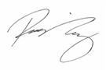

Rick A. Kenny, MAI, SRA Richard J. Kenny

Keystone Valuations LLC Keystone Valuations LLC

rick@ keystonevaluations.com  [richard@keystonevaluations.com](mailto:richard@keystonevaluations.com)

770-823-4954



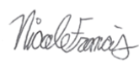

Blake P. Fine, MAI Nicole A. Francis

Keystone Valuations LLC Keystone Valuations LLC

[blake@keystonevaluations.com](mailto:blake@keystonevaluations.com) [nicole@keystonevaluations.com](mailto:nicole@keystonevaluations.com)

**TABLE OF CONTENTS**



# **BASIC ASSUMPTIONS AND LIMITING CONDITIONS**

This appraisal is subject to the following conditions:

1. This appraisal is for no purpose other than property valuation, and the appraiser(s) are neither qualified nor attempting to go beyond that narrow scope. The reader should be aware that there are also inherent limitations to the accuracy of the information and analyses contained in this appraisal. Before making any decision based on the information and analyses contained in this report, it is critically important to read this entire section to understand these limitations.

1. The legal description/survey furnished is assumed to be correct. No responsibility is assumed for matters legal in character nor is any opinion rendered as to the title, which is assumed to be good and marketable. The value estimate is given without regard to any questions of title, boundaries, encumbrances, or encroachments.
2. All existing liens and encumbrances have been disregarded unless otherwise stated, and the property is appraised as though free and clear under responsible ownership and competent management.
3. It is assumed that any proposed or incomplete improvements included in this report are to be completed in accordance with approved plans and specifications and in a workmanlike manner.
4. Information furnished by others is believed to be reliable, but no responsibility is assumed for its accuracy. Information (including projections of income and expenses) provided by local sources, such as government agencies, financial institutions, accountants, attorneys, and others is assumed to be true, correct, and reliable. No responsibility for the accuracy of such information is assumed by the appraiser(s).

The comparable sales data relied upon in the appraisal are believed to be from reliable sources. Though all the comparables were examined, it was not possible to inspect them all in detail. The value conclusions are subject to the accuracy of this data.

1. Any sketches, plats, or drawings included in this report are included to assist the reader in visualizing the property. We have made no survey of the property and assume no responsibility in connection with such matters. Any maps, plats, or drawings reproduced and included in this report are intended only for the purpose of showing spatial relationships. The reliability of the information contained on any such map or drawing is assumed by the appraiser(s) and cannot be guaranteed to be correct. A surveyor should be consulted if there is any concern on boundaries, setbacks, encroachments, or other survey matters.
2. Unless otherwise noted herein, it is assumed that there are no encroachments, zoning restrictions, or violations existing in the subject property. It is assumed that all applicable zoning and use regulations and restrictions have been complied with, unless nonconformity has been stated, defined, and considered in the appraisal report. Information and analysis shown in this report concerning these items is based only on a rudimentary investigation. Any significant question should be addressed to local zoning or land use officials and/or an attorney.
3. It is assumed that all required licenses, consents, or other legislative or administrative authority from any local, state, national government or private entity or organization have been, or can be obtained or renewed for any use on which the value estimate contained in this report is based. Appropriate government officials and/or an attorney should be consulted if an interested party has any questions or concerns on these items since we have not made a comprehensive examination of laws and regulations affecting the subject property.
4. We are not required to give testimony or attendance in court by reason of this appraisal, with reference to the property in question, unless arrangements have been made previously thereof.
5. No responsibility is assumed for engineering matters, either structural or mechanical. Good structural and mechanical conditions are assumed to exist, and no opinion as to these matters is to be inferred or construed from this report. Although the appraisal may contain information about the physical items being appraised (including their adequacy and/or condition), it should be clearly understood that this information is only to be used as a general guide for property valuation and not as a complete or detailed physical report. The appraiser(s) are not construction, engineering, environmental, or legal experts, and any statement given on these matters in this report should be considered preliminary in nature.
6. The observed condition of the foundation, roof, exterior walls, interior walls, floors, heating system, plumbing, insulation, electrical service, and all mechanical systems and construction is based on a casual inspection only and no detailed inspection was made. For instance, we are not experts on heating systems and no attempt was made to inspect the interior of the furnace. The structures were not checked for building code violations, and it is assumed that all buildings meet applicable building codes unless stated in the report.

Some items such as conditions behind walls, above ceilings, behind locked doors, or under the ground are not exposed to casual view and therefore were not inspected. The existence of insulation, if any is mentioned, was found by conversation with others and/or circumstantial evidence. Since it is not exposed to view, the accuracy of any statements about insulation cannot be guaranteed.

It is assumed that there are no hidden or unapparent conditions of the property, subsoil, or structures that would render it more or less valuable. No responsibility is assumed for such conditions, or for the engineering that may be required to discover such factors. Since no engineering or percolation tests were made, no liability is assumed for soil conditions. Subsurface rights (mineral and oil) were not considered in making this appraisal. Wells and septic systems, if any, are assumed to be in good working condition and of sufficient size and capacity for the stated highest and best use.

1. Because no detailed inspection was made, and because such knowledge goes beyond the scope of this appraisal, any observed condition or other comments given in this appraisal report should not be taken as a guarantee that a problem does not exist. Specifically, no guarantee is made as to the adequacy or condition of the foundation, roof, exterior walls, interior walls, floors, heating system, air conditioning system, plumbing, electrical service, insulation, or any other detailed construction matters. If any interested party is concerned about the existence, condition, or adequacy of any particular item, it is strongly suggested that a construction expert be hired for a detailed investigation.
2. Disclosure of the contents of this appraisal report is governed by the Bylaws and Regulations of the Appraisal Institute.

One (or more) of the signatories of this appraisal report is a Member (or Candidate Member) of the Appraisal Institute. The Bylaws and Regulations of the Appraisal Institute require each Member and Candidate Member to control the use and distribution of each appraisal report signed by such Member or Candidate Member. Therefore, except as hereinafter provided, the party for whom this appraisal report was prepared may distribute copies of this appraisal report, in its entirety, to such third parties as may be selected by the party for whom this appraisal report was prepared; however, selected portions of this appraisal report shall not be given to third parties without the prior written consent of the signatories of this appraisal report. Further, neither all nor any part of this appraisal report shall be disseminated to the general public by the use of advertising media or other media for public communication without the prior written consent of the signatories of this appraisal report.

1. The value estimate applies only to the entire property and cannot be prorated to individual portions or fractional interests. Any proration or division of interest will invalidate the value estimate, unless such proration or division of interests is set forth in the report.

The forecasts or projections included in this report are utilized to assist in the valuation process. They are based on current market conditions, current short-term supply and demand factors, and a continued stable economy. These forecasts are therefore subject to changes in future conditions which cannot be accurately predicted by the appraiser(s), and these changes could affect the future income and/or value estimates. Since projected mathematical models and other projections are based on estimates and assumptions which are inherently subject to uncertainty and variation depending upon evolving events, we do not represent them as results that will actually be achieved.

1. In this appraisal assignment the existence of potentially hazardous material such as asbestos, urea formaldehyde foam insulation, radon gas, or any other toxic material, has not been considered. The appraiser(s) are not qualified to detect such substances and, if desired, recommend that the client retain an expert in this field.

Non-disclosure of environmental problems should not be taken as an indication that such a problem does not exist, however an expert in the field should be consulted if any interested party has questions on environmental factors. No chemical or scientific tests were performed by the appraiser(s) on the subject property, and it is assumed that the air, water, ground, and general environment associated with the property presents no physical or health hazard of any kind unless otherwise noted in the report. It is further assumed that the lot does not contain any type of dump site and that there are no underground tanks (or any underground source) leaking toxic or hazardous chemicals into the groundwater or the environment unless otherwise noted in the report.

1. It is assumed that there is full compliance with all applicable federal, state, and local environmental regulations unless noncompliance is stated, defined, and considered in the appraisal report. A comprehensive examination of laws and regulations affecting the subject property was not performed for this appraisal.
2. The subject property may or may not be located in or adjacent to a wetlands area. The appraiser(s) are not qualified in the area of engineering pertaining to the determination of wetlands; therefore, the appraiser(s) are unable to determine the wetlands status of the subject property. In this report, it is assumed the appropriate permit, if required, can be or has been obtained from the U.S. Army Corps of Engineers. It is also assumed that the jurisdictional determination study and/or permit regarding construction in a wetlands area, if required, does not result in the alteration of the subject property description contained in this appraisal report. The appraiser(s) recommend that a pre-application consultation be completed by the property owner with the Corps of Engineers if no permit has been obtained. The client is urged to retain an expert in this field, if desired.
3. The Americans with Disabilities Act (ADA) became effective January 26, 1992. We have not made a specific compliance survey and analysis of this property to determine whether or not it is in conformity with the various detailed requirements of the ADA. It is possible that a compliance survey of the property together with a detailed analysis of the requirements of the ADA could reveal that the property is not in compliance with one or more of the requirements of the act. If so, this fact could have a negative effect upon the value of the property. Since we have no direct evidence relating to this issue, we did not consider possible noncompliance with the requirements of ADA in estimating the value of the property.
4. Opinions and estimates expressed herein represent our best judgment but should not be construed as advice or recommendation to act. Any actions taken by you, the client, or any others should be based on your own judgment, and the decision process should consider many factors other than just the value estimate and information given in this report.
5. The appraiser has not identified any purchaser, borrower, or seller as an intended user of this appraisal and no such party should use or rely on this appraisal for any purpose. Such parties are advised to obtain an appraisal from an appraiser of their choosing if they require an appraisal for their own use. This appraisal report should not serve as the basis for any property purchase decision or any appraisal contingency in a purchase agreement relating to the property.
6. Any reproduction, copy, graphical representation, or analysis of the contents of this report is expressly forbidden without express written consent from Keystone Valuations LLC and/or the parties signing the certification of this report.

# **CERTIFICATION**

We certify that, to the best of my knowledge and belief:

− The statements of fact contained in this report are true and correct.

− The reported analyses, opinions, and conclusions are limited only by the reported assumptions and limiting conditions and is our personal, impartial, and unbiased professional analyses, opinions, and conclusions.

− I have no present or prospective interest in the property that is the subject of this report and no personal interest with respect to the parties involved.

− I have performed no services, as an appraiser or in any other capacity regarding the property that is the subject of this report within the three-year period immediately preceding acceptance of this assignment.

− I have no bias with respect to the property that is the subject of this report or to the parties involved with this assignment.

− My engagement in this assignment was not contingent upon developing or reporting predetermined results.

− My compensation for completing this assignment is not contingent upon the development or reporting of a predetermined value or direction in value that favors the cause of the client, the amount of the value opinion, the attainment of a stipulated result, or the occurrence of a subsequent event directly related to the intended use of this appraisal.

− My compensation is not contingent upon the reporting of a predetermined Fair Market Value or direction in Fair Market Value that favors the cause of the client, the amount of the Fair Market Value estimate, the attainment of a stipulated result, or the occurrence of a subsequent event. Further, my fee has not been based in whole or in part upon a percentage of the appraised Fair Market Value of the property, nor has the fee in any way been contingent upon the appraised Fair Market Value.

− My analyses, opinions, and conclusions were developed, and this report has been prepared, in conformity with the *Uniform Standards of Professional Appraisal Practice* *and in conformity with the Georgia Real Estate Appraisers Classification and Regulations Act, and the Rules and Regulations of the Georgia Real Estate Appraisers Board.*

− The use of this report is subject to the requirements of the Appraisal Institute relating to review by its duly authorized representatives.

− There has been no exclusion of items pertinent to the assignment, nor exclusion of items beyond this assignment.

− Blake P. Fine, MAI, **has** made a personal inspection of the property that is the subject of this report. Rick Kenny, MAI, SRA, Richard Kenny, Candidate for Designation, and Nicole A. Francis, State Certified General, **have not** made a personal inspection of the property that is the subject of this report

− No one else has provided real property appraisal assistance to the undersigned.

− The reported analyses, opinions, and conclusions were developed, and this report has been prepared, in conformity with the Code of Professional Ethics and Standards of Professional Appraisal Practice of the Appraisal Institute.

− The use of this report is subject to the requirements of the Appraisal Institute relating to review by its duly authorized representatives.

− As of the date of this report, Rick Kenny, MAI, SRA and Blake P. Fine, MAI **have** completed the continuing education program for Designated Members of the Appraisal Institute. Richard Kenny, Candidate for Designation, **has** completed the Standards and Ethics Education Requirements for Candidate for Designation of the Appraisal Institute.

MERGEFORMATINET 

Rick A. Kenny, MAI, SRA Richard J. Kenny

State Certified Appraiser State Certified Appraiser

Certified General #628 Certified General #373297

AI#66318



Blake P. Fine, MAI Nicole A. Francis

State Certified Appraiser State Certified Appraiser

Number #260129 Number #417210

# **EXECUTIVE SUMMARY**

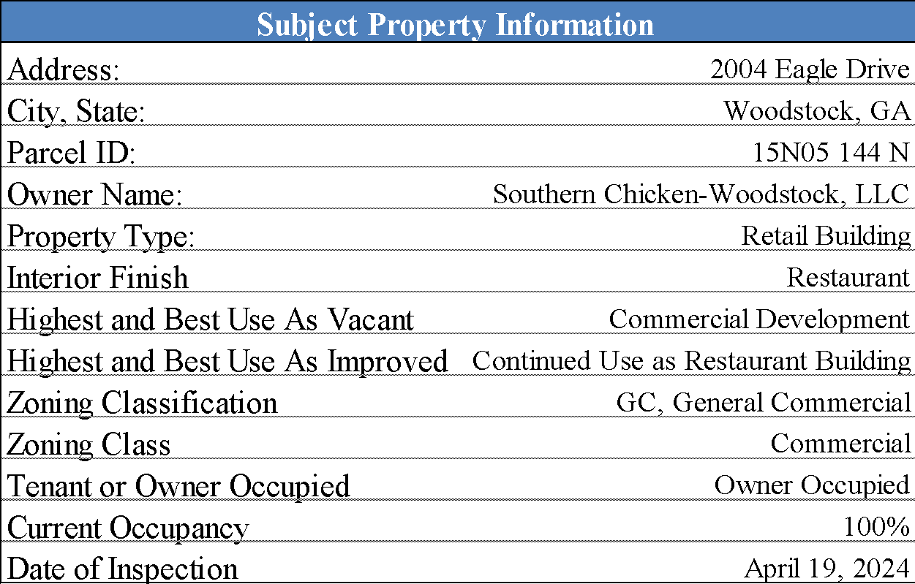

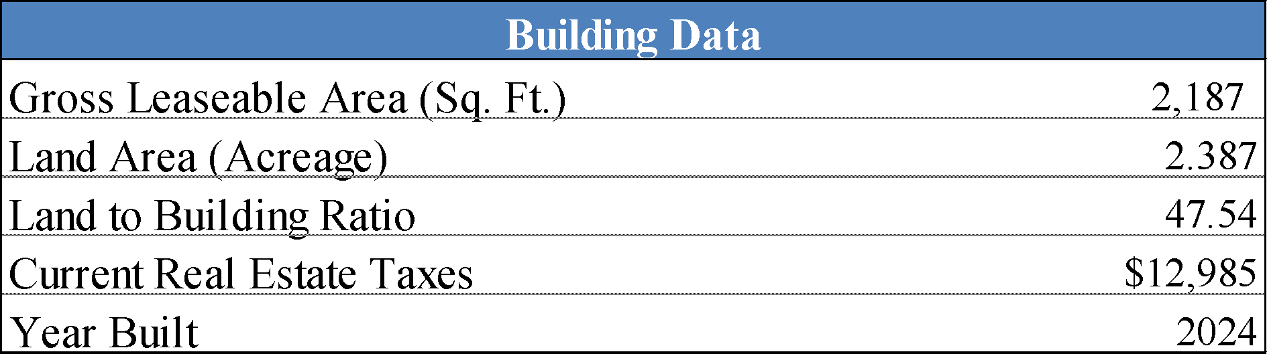

# **VALUE INDICATION**



#### *Subject Photographs*

|  |  |  |
| --- | --- | --- |
| Subject Exterior Front View  (Photo Taken on April 19, 2024) |  | Subject Exterior Drive-Thur View  (Photo Taken on April 19, 2024) |
|  |  |  |
| Subject Exterior Right Side View  (Photo Taken on April 19, 2024) |  | Subject Exterior Rear View  (Photo Taken on April 19, 2024) |
|  |  |  |
| Subject Exterior Left Side View  (Photo Taken on April 19, 2024) |  | Subject Exterior Receptacle Area  (Photo Taken on April 19, 2024) |

Subject Photographs

|  |  |  |
| --- | --- | --- |
| Subject Interior Order Area  (Photo Taken on April 19, 2024) |  | Subject Interior Drive-Thru Area  (Photo Taken on April 19, 2024) |
|  |  |  |
| Subject Interior Kitchen Area  (Photo Taken on April 19, 2024) |  | Subject Interior Kitchen Area  (Photo Taken on April 19, 2024) |
|  |  |  |
| Subject Interior Dining Area  (Photo Taken on April 19, 2024) |  | Subject Interior Dining Area  (Photo Taken on April 19, 2024) |

Subject Photographs

|  |  |  |
| --- | --- | --- |
| Subject Interior Office  (Photo Taken on April 19, 2024) |  | Subject Interior Restroom  (Photo Taken on April 19, 2024) |
|  |  |  |
| Subject Site  (Photo Taken on April 19, 2024) |  | Subject Site  (Photo Taken on April 19, 2024) |
|  |  |  |
| Eagle Drive Looking East  (Photo Taken on April 19, 2024) |  | Eagle Drive Looking East  (Photo Taken on April 19, 2024) |

# **PURPOSE AND DATE OF APPRAISAL**

The purpose of this appraisal is to estimate the Market Value in Fee Simple Estate, *“As Is”*, of the 2,187 sq. ft. Restaurant building located at 2004 Eagle Dr, Woodstock, Cherokee County, Georgia.

# **CLIENT, INTENDED USERS, AND INTENDED USE OF APPRAISAL**

This report is intended for use only by Southern States Bank and Mountain Seed Appraisal Management LLC and/or their affiliates. The use of this report by others is not intended by the appraisers. This report is intended only for loan underwriting and/or credit decisions. This report is not intended for any other use.

**APPRAISER COMPETENCY**

Rick Kenny, MAI, SRA and Certified General Appraiser in Georgia, Blake P. Fine, MAI, and Certified General Appraiser in Georgia, Richard Kenny, Certified General Appraiser in Georgia, and Nicole A. Francis Certified General Appraiser in Georgia, have appraised multiple retail restaurant facilities. Therefore, we have met the requirements of the USPAP Competency Rule.

# **TYPE OF REPORT**

According to the Uniform Standards of Professional Appraisal Practice (USPAP), Standards Rule 2-2, an appraisal report must be prepared under one of the following options and prominently state which option is used: Appraisal Report or Restricted Appraisal Report. These report types are described as follows:

* Appraisal Report: The content must be consistent with the intended use of the appraisal and, at minimum: (i) state the identity of the client and any intended users, by name or type; (ii) state the intended use of the appraisal; (iii) summarize information sufficient to identify the real estate involved in the appraisal, including the physical, legal, and economic property characteristics relevant to the assignment; (iv) state the real property interest to be appraised; (v) state the type and definition of value and cite the source of the definition; (vi) state the effective date of appraisal and the date of the report; (vii) summarize the scope of work used to develop the appraisal; (viii) summarize the information analyzed, the appraisal methods and techniques employed, and reasoning that supports the analysis, opinions, and conclusions; exclusion of the Sales Comparison Approach, Cost Approach, or Income Approach must be explained; (ix) state the use of the real estate existing as of the date of value and the use of the real estate reflected in the appraisal; (x) when an opinion of highest and best use was developed by the appraiser, summarize the support and rational for that opinion; (xi) clearly and conspicuously: (1) state all extraordinary assumptions and hypothetical conditions; (2) and state that there use might have affected the assignment results; (xii) include a signed certification in accordance with Standards Rule 2-3.

* Restricted Appraisal Report: The content must be consistent with the intended use of the appraisal and, at minimum: (i) state the identity of the client, by name or type, and state a prominent use restriction that limits the use of the report to the client and warns that the rational for how the appraiser arrived at the opinions and conclusions set forth in the report may not be understood property without additional information in the appraiser’s work file; (ii) state the intended use of the appraisal; (iii) state information sufficient to identify the real estate involved in the appraisal; (iv) state the real property interest appraised; (v) state the type of value and cite the source of the definition; (vi) state the effective date of appraisal and the date of the report; (vii) state the scope of work used to develop the appraisal; (viii) state the appraisal methods and techniques employed, state the value opinion(s) and conclusion(s) reached, and reference the work file; exclusion of the Sales Comparison Approach, Cost Approach, or Income Approach must be explained; (ix) state the use of the real estate existing as of the date of value and the use of the real estate reflected in the appraisal; (x) when an opinion of highest and best use was developed by the appraiser, state the opinion; (xi) clearly and conspicuously: (1) state all extraordinary assumptions and hypothetical conditions; (2) and state that there use might have affected the assignment results; (xii) include a signed certification in accordance with Standards Rule 2-3.
* The Appraisal Report to be provided is to be labeled as a *Descriptive, Summary, or Restricted Report*. The Appraisal Report must also conform to any State mandated Supplemental Standards. Narrative reports should follow the format outlined in the most recent edition of the Appraisal of Real Estate published by the Appraisal Institute.
  + A *Descriptive* report is one that fully describes the information analyzed, the appraisal methods and techniques employed, and the reasoning that supports the analyses, opinions, and conclusions.
  + A *Summary* report is one that summarizes the information analyzed, the appraisal methods and techniques employed, and the reasoning that supports the analyses, opinions and conclusions.
  + A *Restricted* report is one that states the information analyzed, the appraisal methods and techniques employed, and the reasoning that supports the analyses, opinions, and conclusions.

This report is prepared as an **Appraisal Report**.

# 

# **PROPERTY RIGHTS APPRAISED**

One or more of the following underlined legal estates or interests are valued in this report. Definitions of these estates are quoted from *The Dictionary of Real Estate Appraisal*, Seventh Edition; published by the Appraisal Institute, copyright 2022.

* Fee Simple Estate *"Absolute ownership unencumbered by any other interest or estate, subject only to the limitations imposed by the governmental powers of taxation, eminent domain, police power, and escheat."*
* Leased Fee Estate *A freehold (ownership interest) where the possessory interest has been granted to another party by creation of a contractual landlord-tenant relationship."*
* Leasehold Estate *"The tenant's possessory interest created by a lease."*

The opinion of value developed in this report relates to the **Fee Simple Estate** of the subject property.

**VALUE OPINION**

Opinions of value are typically developed on the basis of one or more of the following dates or situations.

* Market Value "As Is" on the Appraisal Date: Market Value "As Is" on the appraisal date is an opinion of the market value of a property in the condition observed upon inspection and as it physically and legally exists without hypothetical conditions, assumptions, or qualifications as of the date the appraisal is prepared.
* Prospective Market Value "Upon Completion" of Renovation: Prospective market value "upon completion" of renovation is the future value of a property on the date that construction, conversion, or rehabilitation is completed, based upon market conditions forecast to exist as of that completion date.
* Prospective Market Value "Upon Reaching Stabilized Occupancy": Prospective market value "upon reaching stabilized occupancy" is the future value of a property when all improvements have been physically constructed and the property has been leased to its optimum level of long-term occupancy at the market rent level.

The value opinion for the subject property has been reported on the basis of  **Market Value "As Is".**

# 

# **DEFINITION OF VALUE**

**Market Value**

The following definition of *market value* was taken from Title XI of the Financial Institutions Reform, Recovery, and Enforcement Act (FIRREA) of 1989. *(Source: 12 C.F.R. Part 34.42(g); 55 Federal Register 34696, August 24, 1990, as amended at 57 Federal Register 12202, April 9, 1992; 59 Federal Register 29499, June 7, 1994.)*

Federal agencies publishing this definition include the

* Office of the Comptroller of the Currency (OCC) 12 CFR 34, subpart C
* Federal Reserve Board (FRB) 12 CFR 225, Subpart G
* Federal Deposit Insurance Corporation (FDIC) 12 CFR 323
* National Credit Union Administration (NCUA) 12 CFR 722

This definition, published jointly by the OCC, FRS, and FDIC, is referenced in Appendix D of the “*Interagency Appraisal and Evaluation Guidelines”* dated December 2, 2010*.* A very similar definition is also cited in Advisory Opinion 30 of the 2015-2016 version of the Uniform Standards of Professional Appraisal Practice (USPAP), lines 177 to 181.

*“****Market value*** *means the most probable price which a property should bring in a competitive and open market under all conditions requisite to a fair sale, the buyer and seller each acting prudently and knowledgeably, and assuming the price is not affected by undue stimulus. Implicit in this definition is the consummation of a sale as of a specified date and the passing of title from seller to buyer under conditions whereby:*

1. *buyer and seller are both typically motivated;*
2. *both parties are well informed or well advised and acting in what they consider their own best interests;*
3. *a reasonable time is allowed for exposure in the open market;*
4. *payment is made in terms of cash in U.S. dollars or in terms of financial arrangements comparable thereto; and*
5. *the price represents the normal consideration for the property sold unaffected by special or creative financing or sales concessions granted by anyone associated with the sale."*

This definition is used by many well-known entities. FDIC, Fannie Mae, Freddie Mac, the VA, and the FHA, which are governmental agencies or governmentally sponsored agencies, require usage of this definition as well.

# **LEGAL DESCRIPTION**

A narrative metes and bounds legal description is available. Furthermore, the exhibits and descriptions included in this report help to adequately identify and describe the real estate being appraised. This is in compliance with the requirements of the Uniform Standards of Professional Appraisal Practice (USPAP), as adopted and published by the Appraisal Standards Board of The Appraisal Foundation. The applicable requirements are stated in Standards Rule 2-2 (b) (i) which states that “the appraisal report must identify and describe the real estate being appraised.” USPAP comments on this requirement as follows:

“Identifying the physical real estate can be accomplished by any combination of a legal description, address, map reference, copy of a survey or map, property sketch and/or photographs.”

The subject’s Legal Description can be found below.

All of that tract or parcel of land lying and being in Land Lot 938 of the 15th District, 2nd Section, Cherokee County, Georgia.

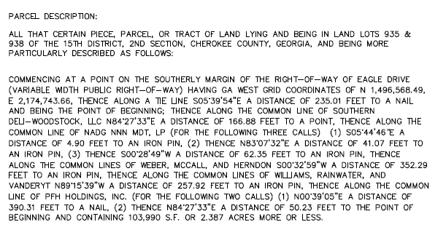

# **SCOPE OF WORK**

The 2023-2024 *Uniform Standards of Professional Appraisal Practice* establishes the “Scope of Work Rule” to guide the process of developing assignment results. Scope of Work is simply the work undertaken in developing the assignment and defined as “the type and extent of research and analyses in an appraisal or appraisal review assignment.” The focus of the scope of work rule is on ensuring that work undertaken is sufficient to develop credible assignment results. Scope of Work is simply the work undertaken in developing the assignment and defined as “the type and extent of research and analyses in an assignment.” The focus of the scope of work rule is on ensuring that work undertaken is sufficient to develop credible assignment results.

An appraisal is generally defined as an opinion of value based on the parameters of the assignment as of a specified date. The valuation of real estate is based on a process of data collection, analysis, and conclusions by a nonbiased third party. The purpose and date of this appraisal, along with the property rights appraised, have been previously defined. Information relating to the subject property also collected includes ad valorem tax data, zoning information, utility availability, floodplain information, topography, frontage, access, and existing improvements. Building plans are reviewed (if applicable) and the site plan studied as to the relationship of the site and the improvements. The improvements are inspected to determine the physical condition and functional utility. Other properties in the neighborhood are inspected to develop an overall opinion of the character, composition, and future trends of the submarket.

**Types of Market Data Researched**

Sales and leases with similar locations, physical traits, zoning, and highest and best use characteristics were analyzed and compared to the subject property where applicable. The appraisers took sufficient steps, common in the industry, to ensure the market data presented in this report are deemed accurate and reliable. The appraisers have made every attempt to confirm and authenticate any expert provided information, however, unless the appraisers found significant information to the contrary, expert provided information is deemed reliable and accurate. Market data included in this report was verified through multiple sources such as, public records of deeds and easements, subscription data sources, including CoStar among others, and interviews with brokers and/or grantors and grantees. Based on the credentials of the experts and the appraisers’ attempt to verify the information, there is no reason at this time to suspect that the provided information is not credible.

**Conclusion**

The scope of this appraisal does not include professional services outside the expertise of the appraiser. These professional services include, but are not limited to, the following: (1) deed restrictions, land use covenants, or other limitations on the property rights that may be revealed by an abstract or title insurance policy; (2) easements, encroachments, or other limitations of the title that may be revealed by a survey; (3) legal matters that require specialized knowledge beyond that ordinarily employed by a real estate appraiser; (4) information typically disclosed by an engineering study or environmental survey; (5) other services covered by the Basic Assumptions and Limiting Conditions set forth in this report.

**WOODSTOCK, CHEROKEE COUNTY, GA REGIONAL AND MARKET AREA DATA**

Real estate market activity is cyclical and subject to the effects of both national business cycles and real estate cycles. The effects of the national business cycle are transmitted to the local economy through the linkages that tie the national economy to the basic industry and employment base of the community. The changing conditions over the successive stages of a cycle result in a shift of supply and demand within the market area.[1] Therefore, knowledge of the fundamental market forces of demand within a community is important for market analysis. These demographic and economic forces are population, employment, and income. By tracking the change in these three categories within a defined market area, the change in demand for various types of real estate can be measured. In general, a change in population is the fundamental source of demand for housing units. Similarly, office space and industrial space are linked to employment, and retail space is linked to the income earned within the market area.[2] Within this report, population and employment will be discussed on a county basis and the income on the specific competitive market area.

**Population**

Cherokee County is one of the top 10 most populous counties in Georgia, with its population steadily increasing over the past few decades. According to the U.S. Census, the population growth has grown significantly since 2010. Between April 2020 and July 2023, Cherokee County’s population has increased by 7.5% compared to the State’s 3% growth. Cherokee County’s current population is approximately 286,535.

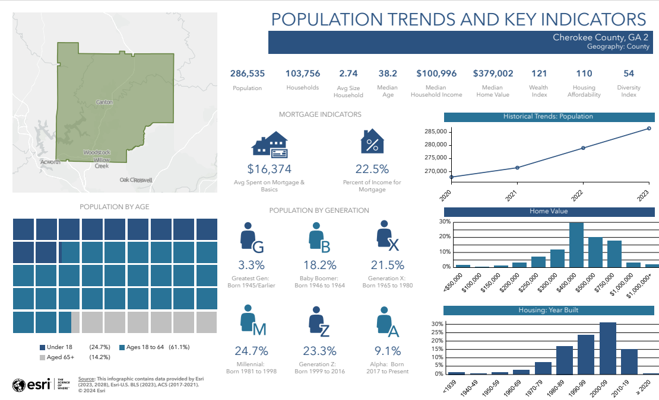

The chart above shows the population trends and key indicators for the subject market. Further, a detailed demographic analysis has been included in the addenda of this report.

Analyzing the population trend for Cherokee County demonstrates it is likely to continue to grow With this in mind the housing sector and ancillary businesses will need to grow as well in order to keep pace. Although the demand for housing, subsidiary office, retail, and industrial space is affected by the growth in population and income earned within the community, the oversaturation in the market for these categories can decrease the demand for new supportive office, residential, retail, and industrial space until the market reaches equilibrium. Market equilibrium occurs when supply meets demand minus frictional vacancy, the space needed for easy movement within the market.

**Employment**

When analyzing the need for development in an area it is important to understand the hierarchy to the fundamental forces of demand. Typically, the engine of growth in a region is business expansion, which leads to employment growth, which leads to housing growth and finally retail growth. Hence, economic and demographic characteristics are indicators of demand, helping to establish future market trends and reflecting the economic prosperity of the region.[3]

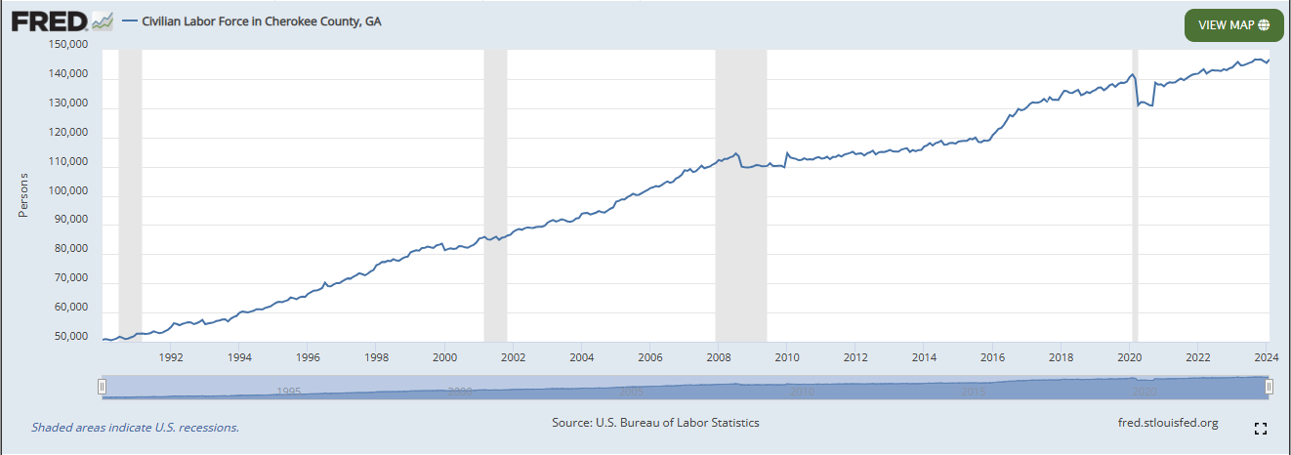

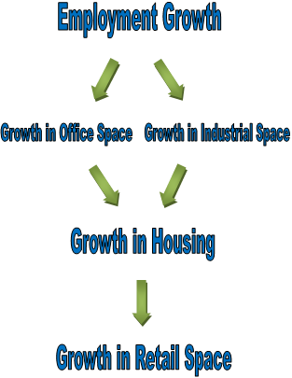

According to the Georgia Department of Labor, the 10 largest employers in Cherokee County are Cherokee County School District, Northside Hospital Cherokee, WellStar Kennestone Hospital, Cherokee County Government, City of Woodstock, Reinhardt University, Kennesaw State University, The Home Depot Distribution Center, Publix Super Markets, and Walmart.

**Unemployment**

The unemployment rate is a good economic indicator and can reflect the demand for retail, office, and industrial space. Cherokee County has followed the rest of Georgia in its unemployment trend since the economic downturn that has affected the nation. Unemployment grew rapidly in 2008 and 2009; until 2010 it remained relatively steady near 8-9%, peaking in July 2009 at 10.1%. However, since 2010, the unemployment rate has demonstrated a sustained overall downward trend prior to the Covid-19 pandemic. Due to the outbreak of Covid 19, unemployment rates have significantly increased in Woodstock during the spring of 2020, notably peaking at 10.3% in Cherokee County during April 2020. However, unemployment rates in Cherokee County have noticeably decreased over the last few years and as of February 2024, Cherokee County’s unemployment rate is 2.5% compared to the statewide rate of 3.1%.

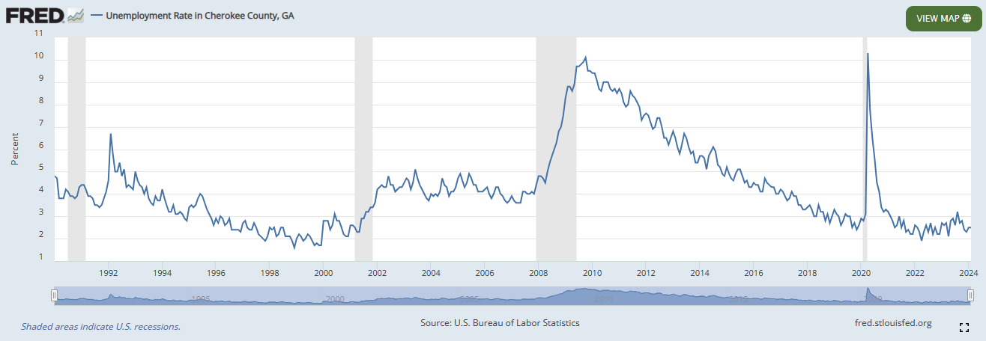

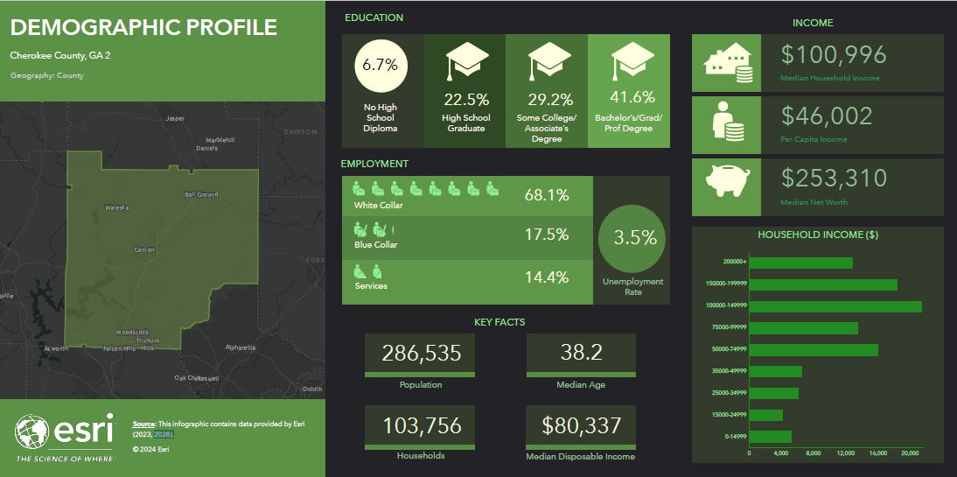

**Competitive Market Area**

The competitive market area is defined as the area where the majority of the competition occurs for the subject property. Within this section of the marketability analysis, the competitive market area of the subject will be defined as within Cherokee Georgia. This was considered appropriate due to the subject’s nature as a restaurant building and the composition of the area.

# **WOODSTOCK, CHEROKEE COUNTY, GA RETAIL MARKET ANALYSIS**

The subject is located within the Woodstock/Cherokee County retail market as designated byb CoStar. The Woodstock/Cherokee County retail submarket has a vacancy rate of 1.6%. This vacancy rate is 0.2% lower than it was this time last year. There have been 63,000 SF of positive absorption and 37,000 SF of net deliveries. Rents have increased 5.6% in the past 12 months and are currently around $21.00/SF. Roughly 22,000 SF is under construction in the Cherokee/Woodstock retail submarket. In the past year, there have been 57 sales, which traded for approximately $135 million in volume. Vacancy is 1.0% in general retail buildings, and 17,000 SF has been absorbed in this asset class over the past year. Vacancy is 1.7% in power centers, and there has been 2,700 SF of negative absorption in this asset class over the past year. Vacancy is 2.5% in strip centers, and there has been 12,000 SF of negative absorption in this asset class over the past year. Vacancy is 2.3% in neighborhood centers, and 60,000 SF has been absorbed in this asset class over the past year. Vacancy is 6.3% in other retail buildings, and absorption has been flat in this asset class over the past year. Current vacancy is lower than its trailing three-year average of 2.4%, which is also lower than the Atlanta market trailing three-year average of 4.0%. Rents have increased 20.0% over the past three years, higher than the Atlanta market average of 19.5%. There have been 250 sales over the past three years, amounting to $611 million in volume and 4.0 million SF of inventory. CoStar's estimated cap rate for Cherokee/Woodstock has averaged 6.8% over the past three years, which is higher than the current estimated cap rate of 6.7%. The total Cherokee/Woodstock retail submarket comprises 14.7 million SF of inventory.

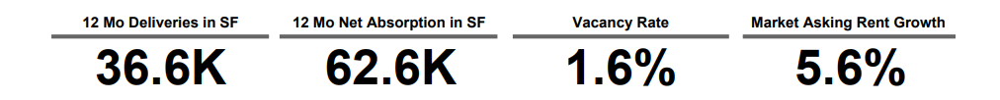

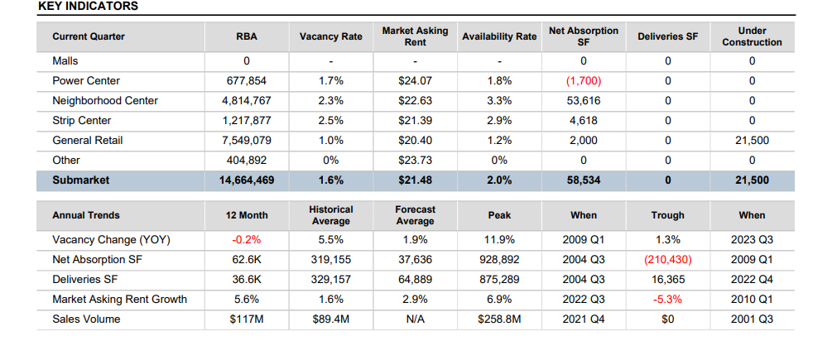

**Leasing**

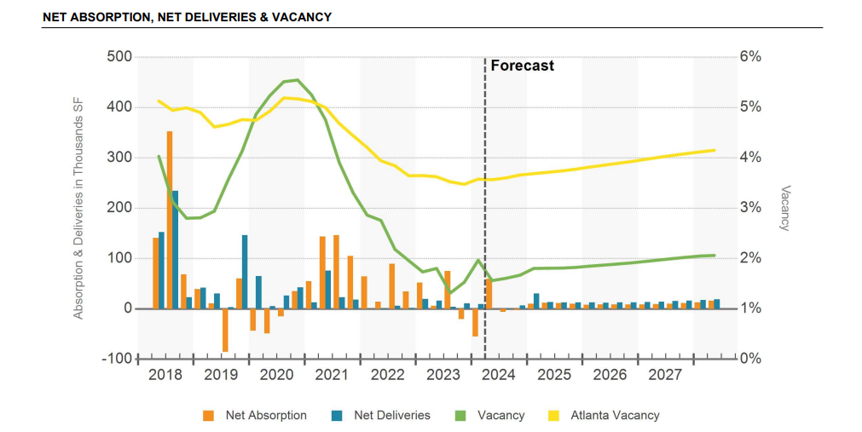

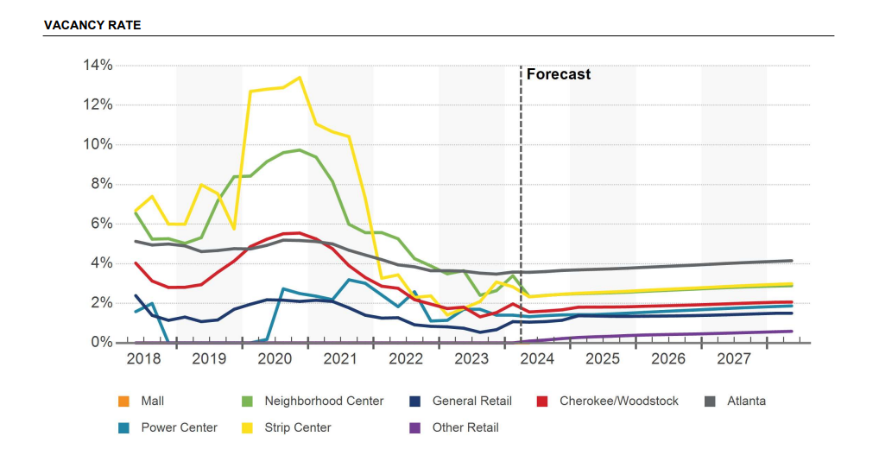

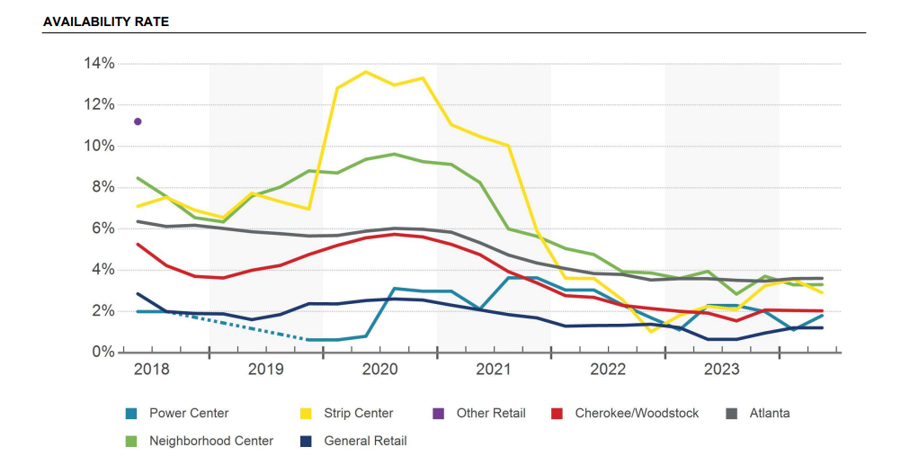

**Rent**

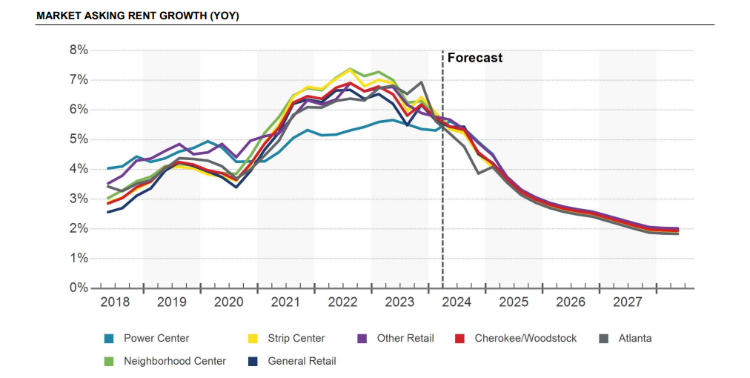

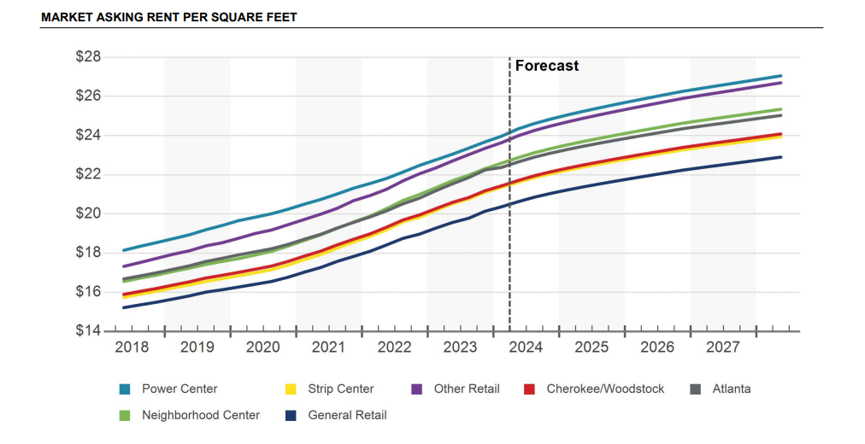

**Construction**

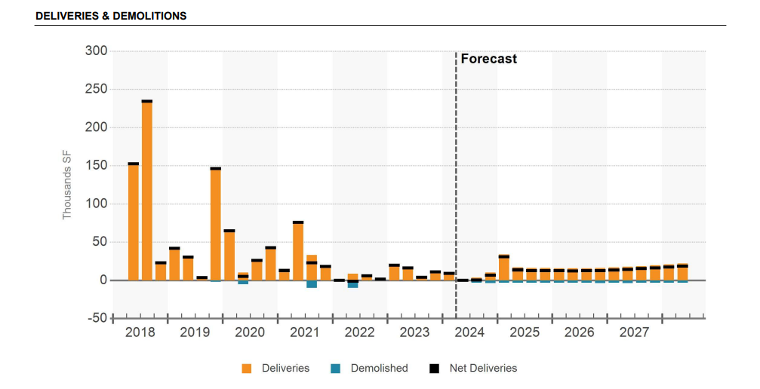

**Sales**

There have been 57 sales in the Cherokee/Woodstock retail submarket over the past year, amounting to $135 million of volume and 950,000 SF of stock. These sales have averaged $216/SF, below the estimated submarket price of $235/SF. During this time, trailing one-year price per SF averages were as high as $217/SF and as low as $185/SF. Over the past three years, Cherokee/Woodstock has averaged 84 sales per year, $201 million of volume per year, and 1.3 million SF of stock per year. Of the sales in the past 12 months, 43 were of general retail. There was one sale of a strip center. Neighborhood centers were sold 8 times. Power centers were sold 5 times. The submarket's current transaction cap rate stands at 5.7%, below the Atlanta market average of 6.5%. Over the past three years, transaction cap rates have averaged 6.4%. Within Cherokee/Woodstock, general retail has market cap rate of 6.4%, power centers have a market cap rate of 7.0%, strip centers have a market cap rate of 6.5%, and neighborhood centers have a market cap rate of 7.2%.

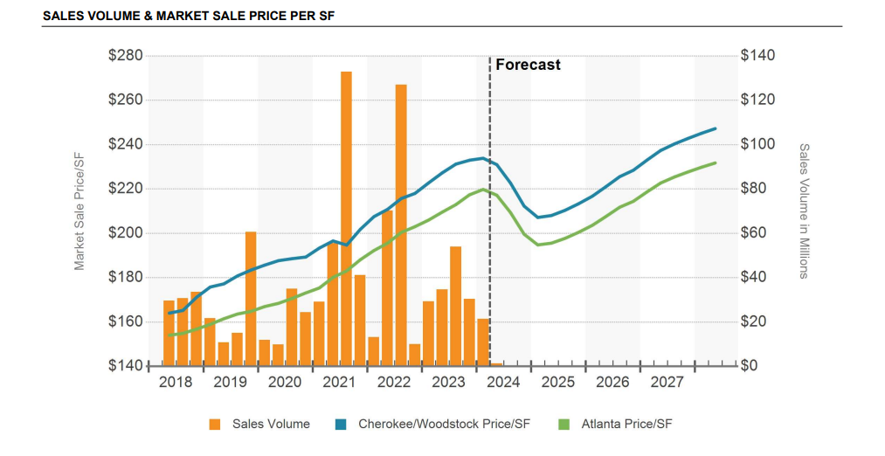

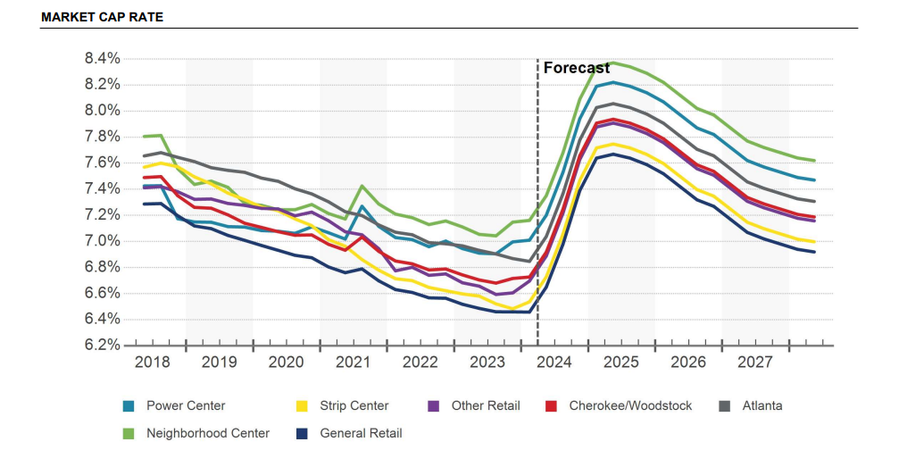

**Conclusion**

Cherokee County’s projected population rate from 2023 to 2028 will increase by 6.8%, which is well above Georgia’s projected population increase rate from 2023 to 2028 of 2.58%. The Cherokee County unemployment rate has been consistently declining since 2010, not considering the spring and summer 2020 unemployment figures caused by the Covid-19 pandemic, currently, Cherokee County’s unemployment rate is 2.5%. As demonstrated by the demographic profile, the population and number of households within the Cherokee County area has increased since 2010, with expanded growth projected through 2028 in the subject’s competitive market area. Despite the Covid-19 pandemic, the economic indicators examined within the competitive market area reveal signs of economic expansion. In the competitive market area, vacancy rates are currently at 1.6%, rental rates have gradually increased, and the unemployment rate is on an overall downward trend. Therefore, based on the above analysis of office space in the Cherokee County submarket, the subject is considered to be in average demand, with the potential for greater demand as the economy continues to expand. Considering the subject’s location, the composition of the competitive market area, and the subject’s compatibility with nearby developments, the subject is considered to be in average demand within this submarket.

It should be noted that this market data covers all retail types and is not specific to the subject’s restaurant property type, which typically carries higher sale price per sq. ft. among other metric differences.

**SUBJECT LOCATION**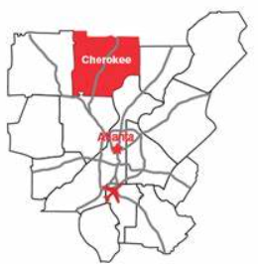

The subject is located on the south side of Eagle Drive, east of Bells Ferry Road, west of Interstate 575, and north of GA Hwy 92 in unincorporated Cherokee County, Georgia with a city of Woodstock mailing address. The subject’s neighborhood is bordered by the following arterial routes: Interstate 575 to the west, GA Hwy 92 to the south, Interstate 75 to the west and GA Hwy 140 to the east.

Eagle Drive serves as a prominent collector road facilitating access to the subject property and neighboring commercial establishments with an estimated vehicles per day of 28,500. Meanwhile, Bells Ferry Road acts as the primary collector road in Cherokee County, running parallel to Interstate 575. Located about 2.5 miles west of the subject, Interstate 575 serves as a crucial north-south artery connecting Ball Ground to Kennesaw and Interstate 75 to the south. GA Highway 92, accessible approximately 2.5 miles south via Bells Ferry Road, functions as a vital east-west corridor linking Cobb County to North Fulton County. Interstate 75, a significant arterial route in Georgia, traverses from the northwest to the southeast, providing access to downtown Atlanta. Additionally, GA Highway 140 serves as an arterial route in the northwestern region of Georgia, connecting areas such as Armuchee and Peachtree Corners across Floyd, Bartow, Cherokee, Fulton, and Gwinnett counties.

The subject is located along Eagle Rd just west of the downtown area of the City of Woodstock. To the south, commercial activity dominates, with a significant commercial hub anchoring the area at the convergence of Main Street and GA Highway 92. Moving east, beyond Interstate 575, the landscape shifts to a blend of residential and commercial developments. North of the subject is the expanding downtown area of the City of Woodstock. West of the subject is mainly residential development, but there are some commercial developments primarily located along Bells Ferry Rd. Notably, the subject property rests approximately half a mile west of the Woodstock Central Business District. Additional amenities and attractions, include Patriots Park, Olde Rope Mill Park, Dixie Speedway, educational institutions like Kennesaw State University, and local schools such as Woodstock Elementary, Woodstock Middle, Kell High, and Etowah High. Additionally, healthcare services are conveniently accessible with the presence of Northside Hospital-Cherokee nearby.

**Conclusion**

Cherokee County has grown rapidly in recent years and the area is continuing a growth trend that exceeds the statewide population growth levels. Due to its location on the northwestern edge of the Metro Atlanta area, Cherokee County has land available for future development. The county has experienced the strongest growth in the southern region of the county, the area closest to employment centers to the south. The City of Woodstock is enhanced by its natural surroundings and recreational amenities, also demonstrating strong population growth over the last decade, growing at a significantly higher rate than the state since 2010. Therefore, based on the demographics and growth patterns in the area, it is the appraiser’s opinion that the long-term prospects for future growth in the subject area are considered average.

## **AREA MAP**

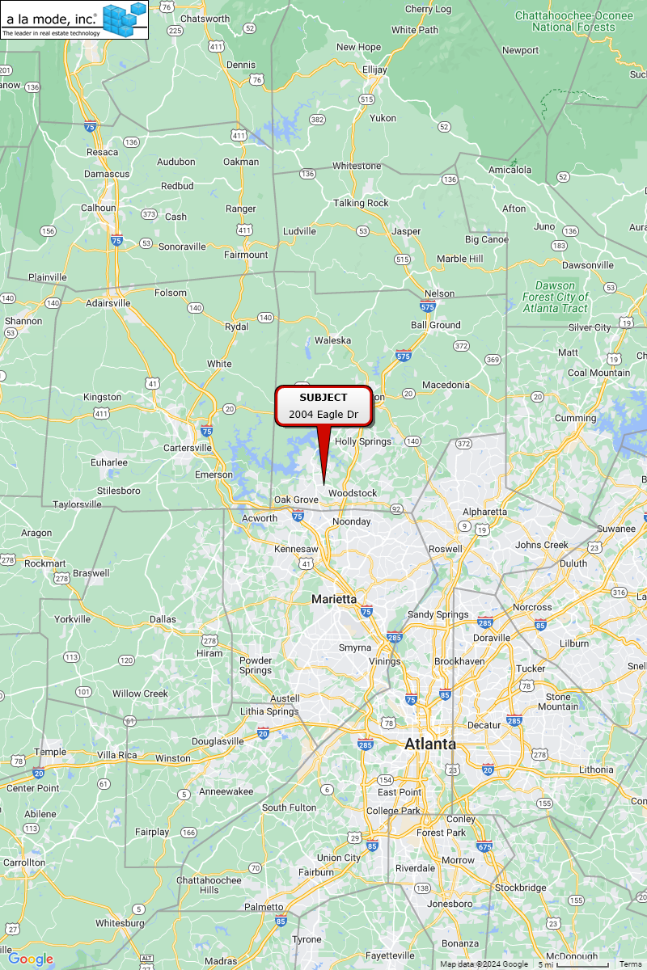

**IMMEDIATE AREA MAP**

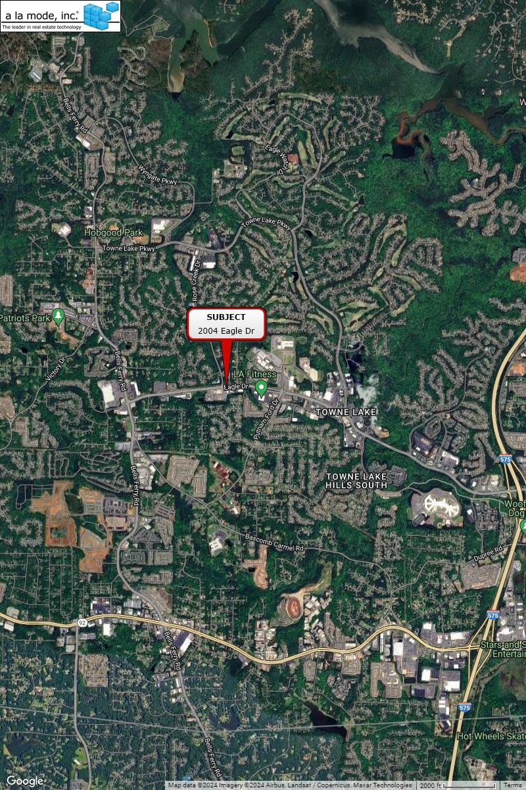

**PROPERTY HISTORY**

Based on the available records the last transaction to occur on the subject property was a Warranty Deed on June 6, 2022, for no consideration, with the grantor being Southern Dli-Woodstock LLC and the grantee being Southern Chicken-Woodstock LLC according to Cherokee County OR Book/Page (14799/2794). This transaction was confirmed by the owner to be inter-related and not arm’s-length in nature. This sale was not considered in our analysis.

The owner reportedely acquired the subject (and it’s adjacent parcel, now a McCallister’s Deli) together on June 29, 2018 for a total consideration of $500,000. The grantor was Hendon/Brand Eagle Drive, LLC according to Limited Warranty Deed 14284/1082. The purchase was reported to have been a land sale with both the subject and the McCallister’s improvements being constructed post-sale.

The subject recently completed construction for a total cost of approximately $1,620,000 (not including the land acquisition). A summarized cost breakdown was provided to the appraisers and is included in the Addenda. The Certificate of Occupancy was issued on April 23, 2024 and the restaurant is set to open on April 30, 2024.

To the best of the appraiser’s knowledge, the subject property has not been listed or sold within the previous three years prior to the appraisal date, except for what is noted above.

The property history has been provided by conversations with various individuals involved with the chain of titles, public records, and CoStar. The appraisers have not performed a title search, nor do the appraisers warrant that the history, as presented herein, is completely accurate since the appraisers have relied upon the information of others. Any person or entity contemplating an interest in the subject property should rely solely upon a title search and opinion prepared by a qualified attorney-at-law.

# **REAL ESTATE TAXES**

Real estate tax assessments are administered by the subject’s municipality in which the subject is located and are estimated by jurisdiction on a county basis. Real estate taxes in this state and this jurisdiction represent ad valorem taxes, meaning a tax applied in proportion to value.

The subject property is taxed by Cherokee County based on an assessment made by the tax assessor. In this case, the statutory assessment rate is 40% of "fair market value”. Real estate taxes and assessments for the current tax year are shown in the following table.

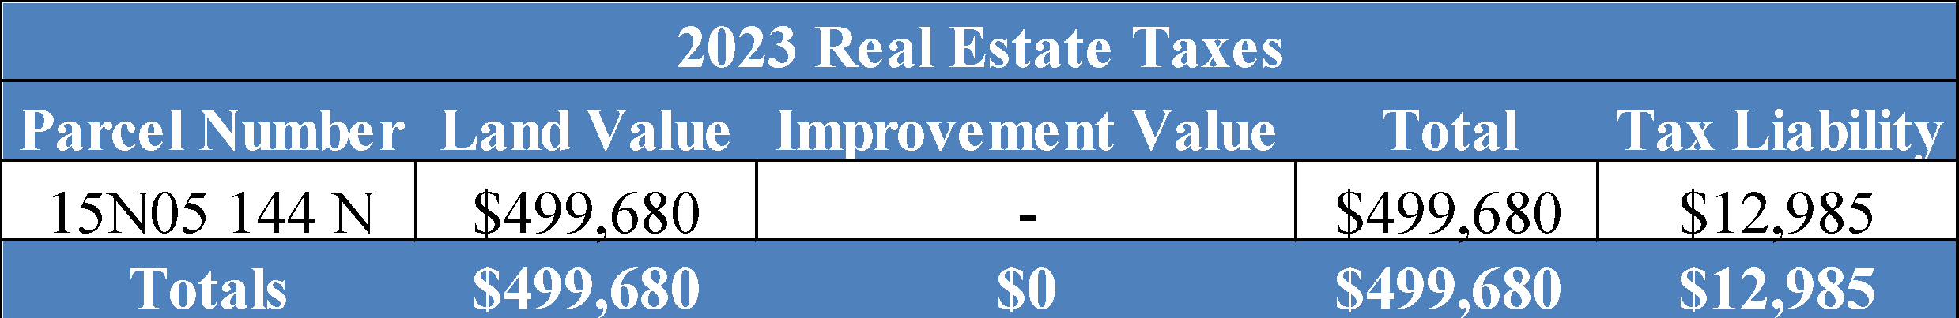

The subject property real estate taxes are due for 2023. Overall, the indicated appraisal value (as of the beginning of the tax year) is above the subject’s fair market value indicated in the chart above.

# **SITE DESCRIPTION**

**Location**

The subject is located on the south side of Eagle Dr, east of Bells Ferry Rd, west of Interstate 575, and north of GA Hwy 92 in unincorporated Cherokee County, Georgia with a city of Woodstock mailing address.

**Site Size**



**Aerial Tax Map**

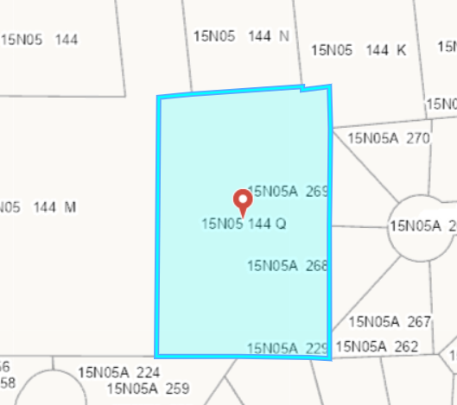

**Frontage, Access, and Topography**

The subject site contains approximately 2.387-acres. The subject site has a deep setback from the main road, Eagle Drive and has access via a common access drive easement (as confirmed by the Survey in the Addenda). Access and visibility to the property is considered below average for a restaurant building within this submarket.

The site is level and has been improved with a 2,187 sq. ft. restaurant building.

**Utilities and Services**

Utilities and services include police/fire protection, water/sewer, electricity, natural gas by a provider of choice, and telephone service.

**Drainage and Soil Conditions**

The building site appears to have adequate drainage with positive flow to the southwest.

The physical inspection of the property did not reveal any apparent evidence of adverse soil or subsoil conditions. A formal study was not undertaken, and we are not qualified to detect such soil conditions. Therefore, we recommend that the client retain an expert in this field of study, if desired.

**Easements, Encroachments and Restrictions**

The appraiser was not provided with a current title report to review. Our valuation assumes no adverse impacts from easements, encroachments, or restrictions, and further assumes that the subject has a clear and marketable title.

**Environmental Hazards**

The physical exterior and interior inspection of the property did not reveal any apparent evidence of hazardous waste materials. A formal study was not undertaken as the appraisers are not qualified to detect such substances and, if desired, recommend that the client retain an expert in the field.

**Site Improvements**

The subject property has a dumpster structure on-site.

**Conclusion**

In conclusion, the site is considered to have average physical utility for the development of a restaurant building. This opinion is based on the site's physical configuration, usable topography, average accessibility, average visibility, and the availability of utilities.

**Survey**

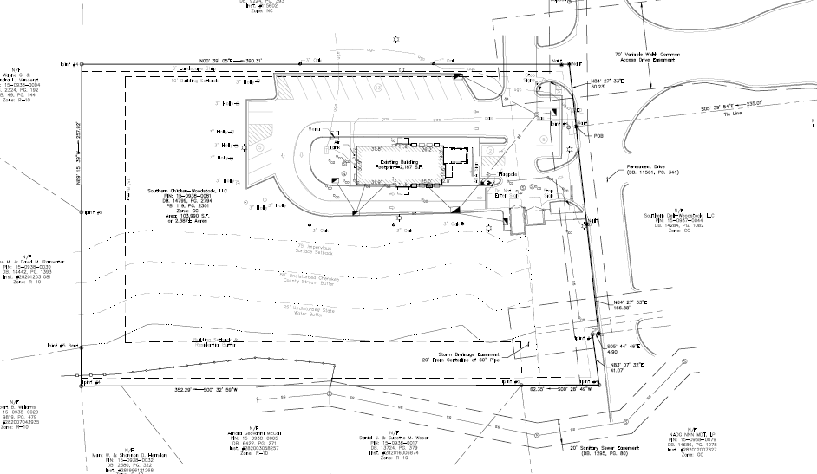

# **FLOOD MAP**

According to Flood Insurance Maps (FIRM) 13057C0327E dated June 7, 2019 the subject is located within Zone X, an area not prone to flooding. The associated flood plain map is shown below.

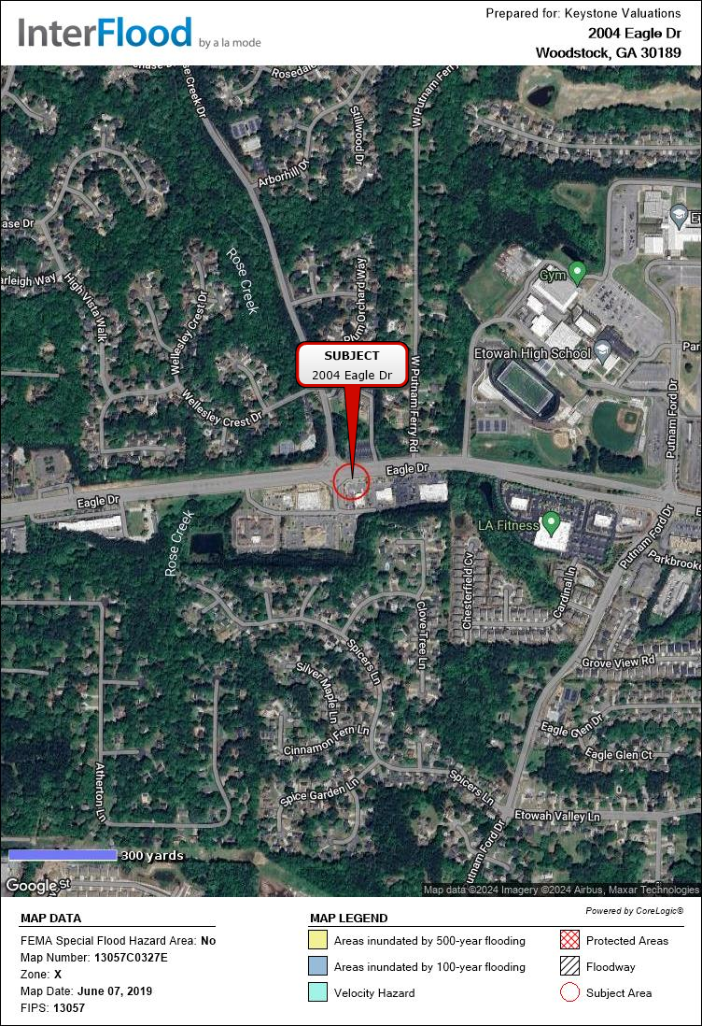

# **IMPROVEMENTS DESCRIPTION**

The subject property is located on the south side of Eagle Drive in Woodstock, Cherokee County, Georgia. The subject property is improved with a one-story restaurant building that contains 2,187 rentable square feet and recently finalized construction. The property improvements and site improvements are fully completed, no further costs are anticipated, and the restaurant just received its Certificate of Occupancy. It is expected to open to the public on April 30th, 2024. The property is owner-occupied and will operate as a Guthrie’s Chicken. The property is situated on one tax parcel which contains 2.387-acres. The subject is zoned as GC, General Commercial District by Cherokee County.

**Overall Improvement Discussion**

The rentable area of a floor is normally computed by measuring to the inside finished surface of the dominant portion of the permanent outer building walls, excluding any major vertical penetrations of the floor. No deductions are made for columns and projections necessary to the building.

Theoverall building and site improvements are in excellent condition as of the date of the appraisal as they were recently completed. Thus, the property has good overall market appeal. Further, the descriptions below are based on a combination of a Keystone inspection, public records and/or broker provided information.

**Effective Age and Economic Life**

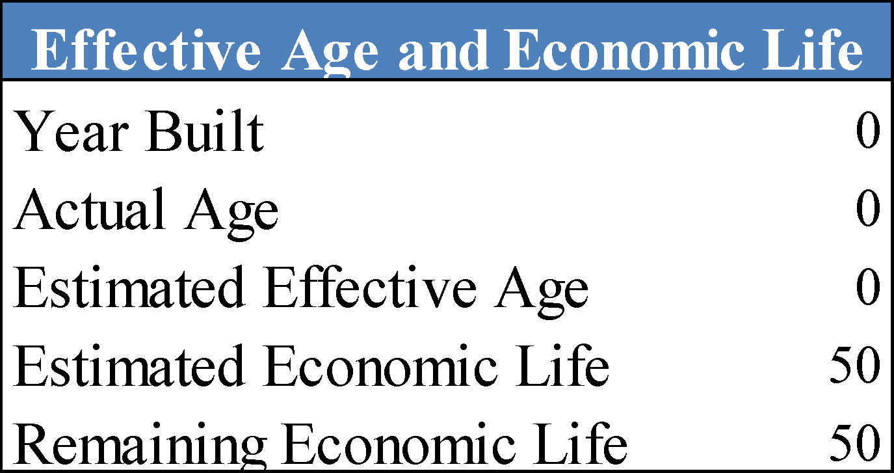

**General Construction Details**

**Footing & Foundations** : Concrete over 4" gravel base with reinforced concrete footings. Assumed.

**Roof** : Flat, material unviewable

**Exterior Walls** : Masonry/Brick

**Interior Walls** : 1/2” Painted Sheetrock, Tile Covering

**Floors** : Tile, Painted Concrete

**Ceilings** : 2x2 acoustical tile, painted drywall

**Electrical** : Assumed Adequate

**Lighting** : Can Lighting Throughout

**Plumbing** : Assumed Adequate

**HVAC** : Central HVAC

**Windows and Doors** : Double Pane Windows in Wood Casing Throughout, Assumed. Aluminum frame and glass with solid interior wood doors, Assumed.

**Fire Security**  : Hand-held fire extinguishers are strategically placed throughout, Assumed.

**Sprinkler** : None

**Parking** : 25 Total Parking Spaces per the Survey. The condition of the asphalt parking area is in excellent condition.

**Deferred Maintenance (or Capital Expenditures)**

The subject does not have any applicable deferred maintenance.

**Furniture, Fixtures & Equipment (FF&E)**

Due to the scope of work, FF&E was not considered in this report.

**Americans with Disabilities Act**

Based on the inspection and information provided, I am not aware of any ADA issues. However,

I am not an expert in ADA matters, and further study by an appropriately qualified professional

is recommended to assess ADA compliance.

**Floor Plan**

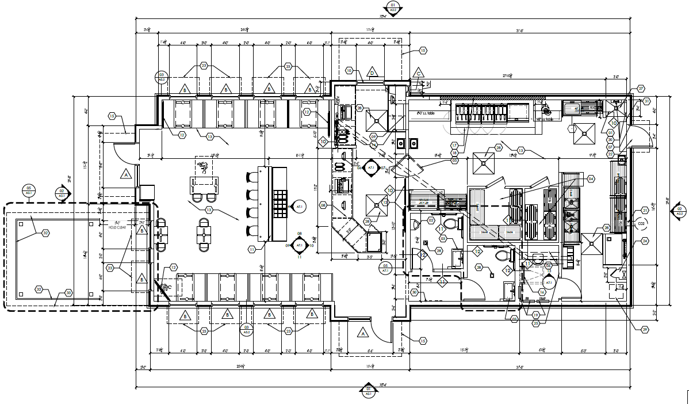

# **ZONING**

The subject property is zoned GC, General Commercial District by the Cherokee County Zoning Department. The purpose of this district is to provide sufficient space in appropriate locations for a wide variety of commercial sales and service activities which generally serve a wide area. The permitted uses are generally located along the major thoroughfares of the county. Activities with limited storage may be permitted. Districts are located to create centers or concentrations of commercial activities and to discourage commercial strip development.

Permitted uses include: retail businesses, restaurants, public offices, medical offices, cultural facilities, animal hospitals, day care facilities, and a variety of other compatible commercial uses. Prohibited uses include single-family dwellings, mobile home park, heavy industrial, and a variety of other prohibited uses.

Limitations include: a minimum front setback of 50 feet abutting a local road, 75 feet adutting an arterial route, a minimum rear setback of 35 feet, and a minimum side setback of 15 feet.

While this is not intended to represent a legal opinion, the subject improvements are considered to be in conformity with the zoning ordinance.

*(Cherokee County Zoning Map)*

# 

# **HIGHEST AND BEST USE**

Highest and Best Use is defined in Chapter 17 Page No. 306, in the 15th edition of "The Appraisal of Real Estate", published by the Appraisal Institute, and adopted by FDIC as the reasonable and probable use that supports the highest present value of vacant land or improved property, as defined, as of the date of the appraisal. Also implied within these definitions is that the determination of highest and best use results from the appraiser's judgment and analytical skill, i.e. that the highest and best use determined from analysis represents an opinion, not a fact to be found. The use of a property must be physically possible, legally permissible, financially feasible, and maximally productive to represent the highest and best use.

In cases where a site has existing improvements, the highest and best use may very well be different from the existing use. However, the existing use will continue unless and until the land value, in its highest and best use, represents the premise upon which value is based.

***Highest and Best Use As Improved***

**Legally Permissible**

As detailed in the zoning section of this report the subject is currently zoned GC, General Commercial District. The site and improvements appear to meet the legal requirements of the current zoning ordinance. Therefore, the subject property conforms to the area’s zoning restrictions and its land use is considered consistent with the subject property’s location and nature of the market area. In general, the subject property’s location is suited for restaurant building development due to its commercialized location.

The possibility of rezoning the site for other uses other than a commercial (neighborhood) district was also considered. However, any zoning other than commercial use, (i.e. agricultural or residential) would not be considered a logical alternative, since it would be inconsistent with the subject’s position along Eagle Drive surrounded by other similar commercial uses.

**Physically Possible**

The physical characteristics of a site that affect its possible use(s) include, but are not limited to, location, street frontage, size, street access, availability of utilities, easements, soil and subsoil and topography.

The site is mostly rectangular and large enough, with a suitable configuration for commercial development. No adverse easements were observed, and there is currently ingress/egress from Eagle Drive. All utilities are available to the site. No soil or subsoil is known to have an adverse effect upon the development potential of the site. Of the uses that are possible, a restaurant building would be physically possible.

**Financially Feasible**

The subject site is located in a commercial and residential area. Commercial, and mixed-use developments in this area have been successful in the past, due to the location, accessibility, proximity to primary transportation routes and the overall desirability of the area as well as its proximity to other employment centers and arterial routes.

The rate of population in Woodstock and Cherokee County has decreased over the last few years while the employment growth in the same area has gradually increased, thereby creating a demand for commercial and residential development. Additionally, the subject’s market area has the necessary characteristics and infrastructures to sustain further growth and development in the future as the economy expands, reinforcing market demand for the subject site.

The subject site is large enough to permit the development of a commercial building, specifically a restaurant building. The property’s expected future capacity for generating a net income in excess of expenses suggests that the current restaurant building would be financially feasible at this time.

**Maximally Productive**

In order to determine the type of development that would result in maximum productivity from the subject property, an analysis was performed. There are no other legally permissible or physically possible uses that could produce a greater positive cash flow other than the current office building, as it is the appraisers’ opinion use of the subject property for agricultural or residential uses is not considered reasonably probable given the subject property location, topography, zoning, access, physical characteristics, and its location near existing commercial buildings.

Based on the definition of maximally productive, the selected land use must yield the highest value of the possible uses.[4] As provided above, there are no other possible uses that are legally permissible, physically possible, and potentially financially feasible, other than as an office building, and it is the appraisers’ opinion that the use that yields the highest value of as an office building. As presented in the analysis found later in this report, a restaurant building is capable of producing a positive net income. Furthermore, due to the projected demand found in the subject property area and the positive net income indicated by the Income Approach, it is the appraisers’ opinion that there is not any other physically possible, legally permissible, or financially feasible use that would be more productive than commercial use, specifically as a restaurant building. Therefore, a restaurant building is considered to be the maximally productive use of the subject property.

**Highest and Best Use - As Improved Conclusion**

The subject property has GC, General Commercial District Zoning; the site has no inherent physical characteristics which might limit its use as a commercial development. The site and improvements appear to meet the legal requirements of the current zoning ordinance. Based on analyses found in this appraisal, the current restaurant building would meet the test of feasibility by producing a positive net income. Other uses may meet the test of economic feasibility; however, continued use as a restaurant building is considered maximally productive. Therefore, the Highest and Best Use, as improved, is its continued use as a restaurant building.

**Highest and Best Use - As If Vacant Conclusion**

Given the site’s functional physical characteristics, size and GC, General Commercial District zoning, commercial development seems probable. Commercial development would be physically possible and legally permissible and would also be compatible with the surrounding improvements. Based on current cost figures found in the appraiser’s files including land, the financial feasibility for a new commercial development under current regional market conditions reveals that development of such a project on the subject’s site would produce a positive cash flow and/or an adequate return to the cost of the improvements. Therefore, based on these considerations, developing as a commercial development is considered the highest and best use, as if vacant.

# **APPRAISAL METHODOLGY**

Three basic approaches may be applicable and utilized, then reconciled to arrive at an estimate of market value. An approach to value is included or eliminated based on its applicability to the property type being valued and the information available. The reliability of each approach depends on the availability and comparability of market data as well as the motivation and thinking of purchasers. Applicable approaches and whether they were utilized are summarized below:

**Cost Approach**

The Cost Approach is based on the proposition that an informed purchaser would pay no more for the subject than the cost to produce a substitute property with equivalent utility. In the Cost Approach, the appraiser forms an opinion of the cost of all improvements, depreciation from physical, functional, and external causes. The land value, entrepreneurial profit and depreciated improvement costs are then added, resulting in indication of value.

**Sales Comparison Approach**

The Sales Comparison Approach compares sales of similar properties with the subject property. Each comparable sale is adjusted for its inferior or superior characteristics. The values derived from the adjusted comparable sales form a range of value for the subject. A gross income multiplier and / or effective gross income multiplier may also be analyzed. By process of correlation and analysis, a final indicated value is derived.

**Income Approach**

In the Income Capitalization Approach the income-producing capacity of a property is estimated by using contract rents on existing leases and by estimating market rent from rental activity at competing properties for the vacant space. Deductions are then made for vacancy and collection loss and operating expenses. The resulting net operating income is divided by an overall capitalization rate to derive an opinion of value for the subject property. The capitalization rate represents the relationship between net operating income and value. This method is referred to as Direct Capitalization.

Related to the Direct Capitalization Method is the Yield Capitalization Method. In this method periodic cash flows (which consist of net operating income less capital costs) and a reversionary value are developed and discounted to a present value using a discount rate or an internal rate of return. The Income Approach converts the anticipated flow of future benefits (income) to a present value estimate through a capitalization and or a discounting process.

**Final Reconciliation**

The appraisal process concludes with the Final Reconciliation of the values derived from the approaches applied for a single estimate of market value. Different properties require different means of analysis and lend themselves to one approach over the others.

**Analyses Applied**

Applicability and utilization of the approaches in this assignment is described as follows.

| **Approach** | **Description** | **Applicability** | **Utilization** |
| --- | --- | --- | --- |
| Cost | A cost approach is most applicable in valuing new or proposed construction when the improvements represent the highest and best use of the land and the land value, cost new and depreciation are well supported. | Applicable | Utilized |
| Sales Comparison | A sales approach is most applicable when sufficient data on recent market transactions is available and there is an active market for the property type. | Applicable | Utilized |
| Income | An income approach is most applicable when the subject is an income producing property or has the ability to generate income in the future as an investment. | Applicable | Utilized |

**Going Concern Analysis**

A going-concern analysis was considered in this appraisal report. In this case, the subject property is an owner-operated restaurant. Typically, there could be inherent values associated with the subject’s FF&E/equipment and intangibles/business. However, given the new construction of the subject, the lack of historical income and expenses, and the lack of projected cash flows or in-place business income, a going-concern analysis was not conducted, and is beyond the scope of this assignment.

# **LAND VALUE METHODOLOGY**

In the appraisal of vacant land, the Sales Comparison Approach is typically used. This method is based on the premise that suggests that the value of a property tends to be set by the cost of acquiring an equally desirable substitute property. The value estimate is predicated on prices paid for similar properties in "arm's length" market transactions over a time period that reasonably reflects market conditions. Therefore, the validity of the Sales Comparison Approach depends on the existence of recent sales of property which are comparable in utility, location, size, shape, sale date, and overall market appeal.

It has been noted that, under certain market conditions, real estate is sold on other than a cash basis, i.e. seller assisted with atypical financing conditions. Such sale terms tend to affect the price paid for the property and often result in artificial values.

**Cash Equivalency**

To properly recognize such transactions, it is necessary to adjust for "Cash Equivalence" to arrive at an estimate of its value under a cash basis without seller incentives.

Cash Equivalency is defined as follows:

An analytical process in which the sale price of a transaction with nonmarket financing or financing with unusual conditions or incentives is converted into a price expressed in terms of cash.

*Source: Appraisal Institute, The Dictionary of real Estate Appraisal, 7th ed.*

In this regard, we have reviewed the comparable sales to be certain that they fall into cash equivalent terms.

The appraisers have researched comparables for this analysis, which are documented on the following pages followed by a location map and analysis grid. All sales have been researched through numerous sources and, when possible, verified by a party to the transaction. Data sheets pertaining to these sales can be located in the addenda of this report.

# **LAND COMPARABLE SUMMARY**

The most relevant and recent sales in the subject size range are presented in the summary chart below. On the following pages is a map of the land sale comparables, an adjustment discussion, and the sale comparison grid.

# 

# **LAND COMPARABLE MAP**

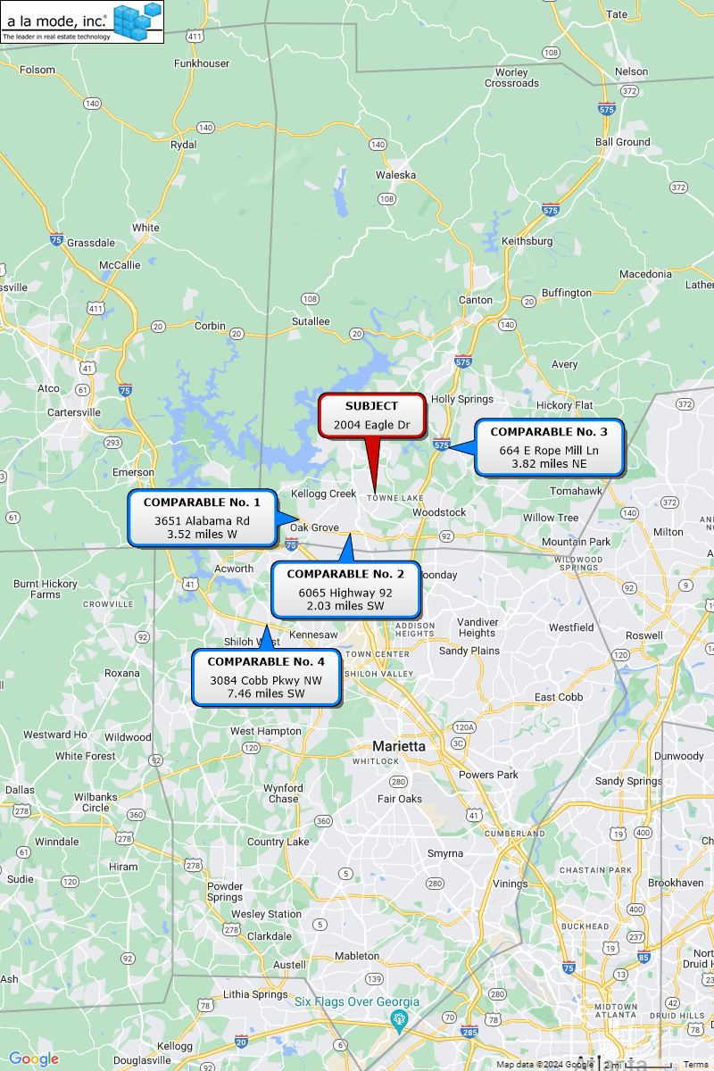

**Land Sales Adjustments**

The previous sales have been analyzed and compared with the subject property. Adjustments are considered for the following factors, in the sequence shown below.

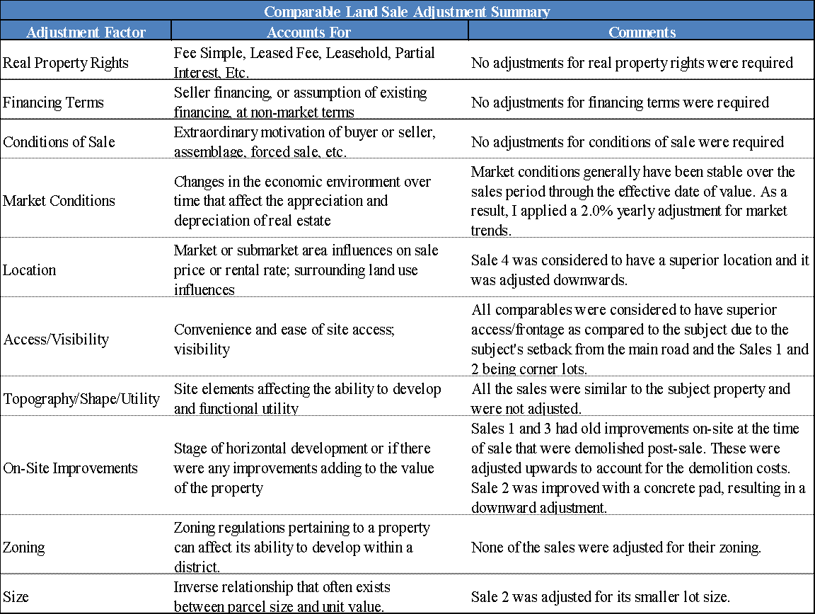

The adjustment grid on the next page contains these adjustments.

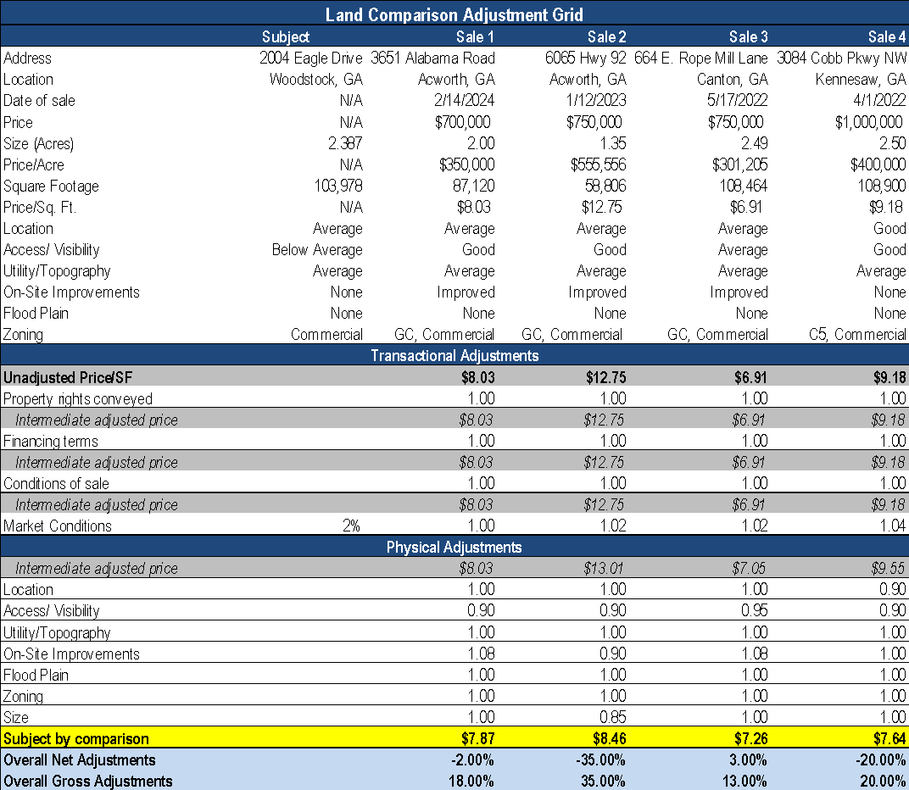

**Land Value Conclusion**

After adjustments, the sales ranged from $7.26 per sq. ft. to $8.46/sq. ft., with an average of $7.81 per sq. ft. and a median of $7.76 per sq. ft. Sales 1 and 3 are considered to be the most comparable. Secondary consideration was given to the remaining sales.

After considering all sales with respect to location, size, site utility, topography, road frontage, and market demand, the value of the subject site is estimated at $7.50 per sq. ft. or:

103,978 sq. ft. x $7.50/SF = $779,833

**LAND VALUE ROUNDED $780,000**

# **COST APPROACH**

The Cost Approach is based on the principle of substitution, considering that no prudent investor would pay more for a property than the amount for which the site can be acquired and for which improvements that have equal desirability and utility can be constructed without undue delay. An inherent weakness in the Cost Approach is the required estimation of depreciation. Depreciation from all causes, especially obsolescence, can exist in new properties, which tends to weaken the validity of the Cost Approach.

In order to provide an opinion of the value of the improvements, the *Marshall Valuation Service* (MVS) cost manual published by Marshall & Swift was reviewed. The MVS is an authoritative appraisal guide for developing replacement cost, depreciated values, and the insurable values of buildings and other improvements. It provides costs for a wide range of construction classes and types of occupancies. Modifiers are included to make the cost applicable to any size building in any locality. The service is updated monthly to provide up-to-date cost multipliers, building cost indexes, and complete revisions of sections of the manual. The class of construction is a basic division in the MVS, dividing all buildings into five basic cost groups by type of framing (supporting columns and beams), walls, floors, roof structures, and fireproofing.

* Class “A” buildings have fireproofed structural steel frames with reinforced concrete or masonry floors and roofs.
* Class “B” buildings have reinforced concrete frames and concrete or masonry floors or roofs.
* Class “C” buildings generally have a wood frame, floor, and roof structure. They may have a concrete floor on grade and other substitute materials but is considered combustible construction. This class includes wood pole frame buildings.
* Class “S” buildings have frames, roofs, and walls of incombustible metal. This class includes pre-engineered metal buildings.

Within MVS, each property has a quality scale against which most buildings and their parts must be rated. **These quality scales are Low Cost, Average, Good and Excellent**.

The base per square foot cost derived by using the MVS includes the following costs:

* Average architect and engineer’s fees, including plans, plan check, building permits and surveys to establish building lines and building grades.
* Normal interest on building funds during the period of construction and processing fee or service charge.
* Sales taxes on materials
* Normal site preparation includes excavation for foundation and back fill.
* Utilities from structure to lot line for typical set back.
* Contractor’s overhead and profit including job supervision, workman’s compensation, fire and liability insurance, and unemployment insurance.

**Direct Costs - Improvements**

The subject property is improved with a 2,187 sq. ft. retail restaurant building built in 2024. The improvement is an Good Class C Restaurant – Fast Food building. According to the *Marshall Valuation Service*, the cost new for the subject is $305.00/sq. ft. Current and local multipliers have been factored in as shown below to arrive at an adjusted base cost of $312.93/ sq. ft. .

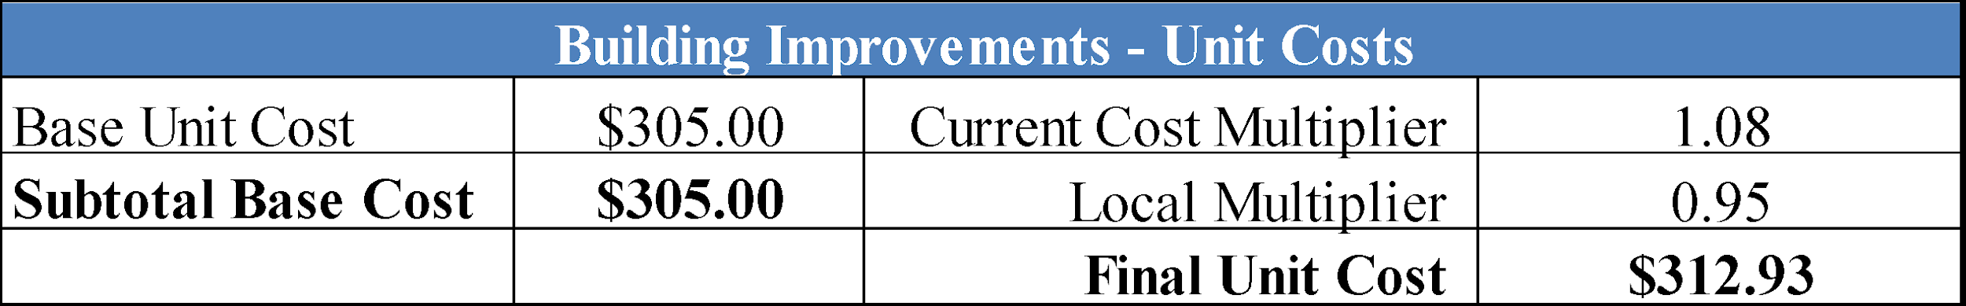

**Direct Costs – Site Improvements**

The subject site improvements consist of a parking area, lighting, and other yard improvements. From MVS, these costs are estimated at $3.00/sq. ft.

**Indirect Costs**

MVS does not include all of the indirect costs (soft costs) that are appropriate in a replacement cost estimate. Therefore, we add an allowance for indirect costs that are not contained within our direct cost estimate: taxes and carrying costs on land during construction; legal, appraisal and accounting fees; and marketing and financing costs. These costs typically range from 2.0% to 10.0%. In this case, this cost is estimated at 8.0% in this analysis.

**Entrepreneurial Profit**

In order to accurately reflect market value from the Cost Approach, some increment of entrepreneurial profit should be included. As indicated on Pages 573 to 576 of *The Appraisal of Real Estate,* Fifteenth Edition, published by the Appraisal Institute.

“*Entrepreneurial profit is the difference between total cost of development and marketing and the market value of a property after completion and achievement of stabilized occupancy and income”. “When the direct and indirect costs of developing a property are used to provide an indication of value, the appraiser must also include an economic reward sufficient to an entrepreneur to incur the risk associated with a building project*”.

Based on our knowledge of and experience with what market players perceive to be a reasonable profit and conversations with regional construction developers, as well as local developers, a return of 10% to 25% of improvement cost, would be necessary for entrepreneurial profit. This cost is estimated at 15% in this analysis.

**Developers Costs**

The developer’s estimated completion costs for the subject property are summarized below. Items related to these costs can be found in the addenda of this report.

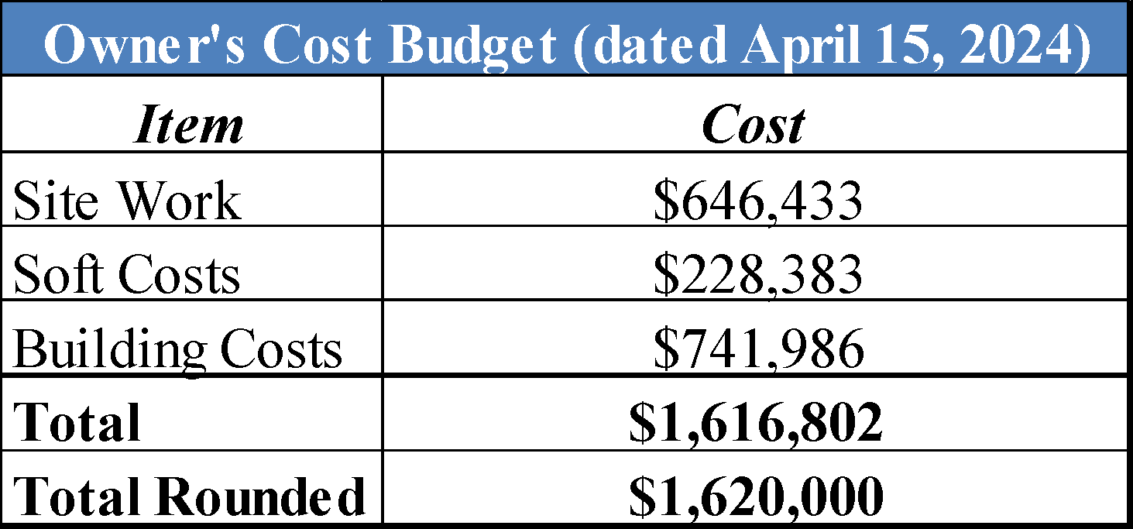

In comparison, the Marshall Valuation Service cost figures are lower than the cost as provided by the developer. Therefore, the comparison is not completely apples to apples. In this analysis, the cost estimates rely on the Marshall & Swift data.

**Accrued Depreciation**

In estimating depreciation, the appraisers have considered the various forms of depreciation affecting the subject property. All methods of estimating deprecation consider age-life relationships either directly or indirectly. The overall concept of depreciation as used in appraisals is based on age and life relationship, which relate to the entire improvement and also to its various components. Depreciation occurs over the life of an improvement or a component; in theory an improvement or component loses all its value over its life.

Curable Physical Deterioration – Curable physical deterioration refers to items of deferred maintenance, i.e., items in need of repair. It is the appraiser’s opinion that the existing structure has no deferred maintenance.

Incurable Physical Deterioration -Incurable physical deterioration are items of deterioration that cannot be practically or economically corrected at present. In this analysis, the subject’s depreciation by the age life method is estimated to be 0.00%. Details and calculations of the subject are as follows:

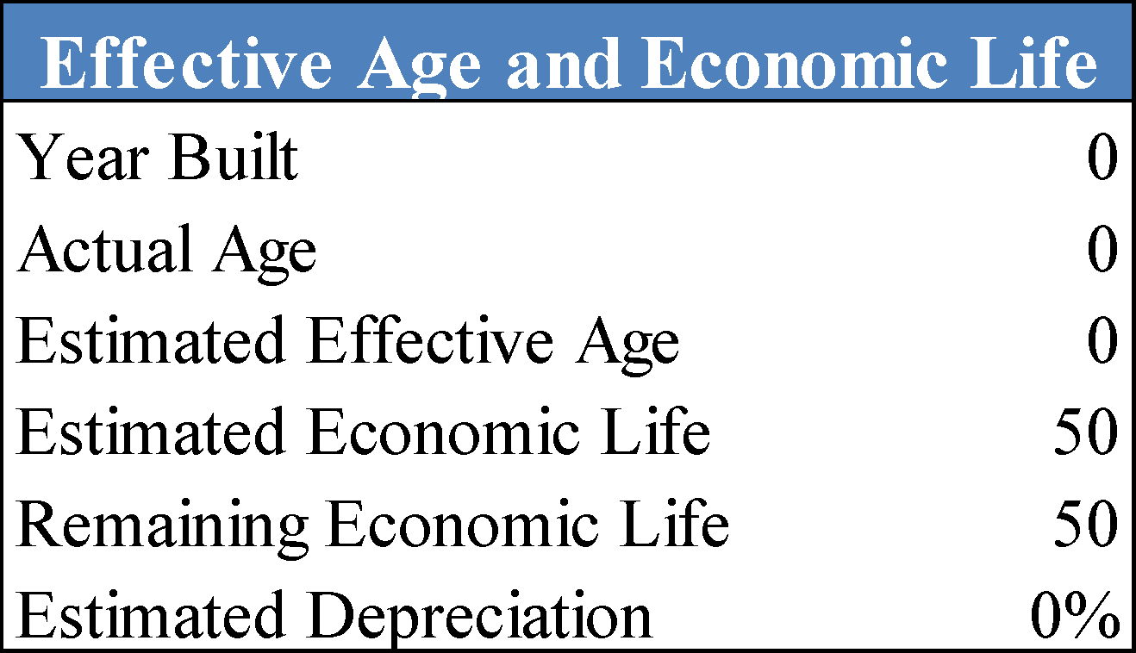

Functional Obsolescence – Functional obsolescence is a loss in value due to defects in design. The defect may be curable or incurable and is caused by changes that have been made to some aspect of a structure, such as materials or design obsolete by current standards. The subject is not deemed to have any functional obsolescence.

External Obsolescence – External obsolescence is the diminished utility of a structure due to negative influences emanating from outside the building. It can be caused by a variety of factors including neighborhood decline, the property’s location in a community or region, or local market conditions. A deduction for external obsolescence is not considered necessary for the subject.

# **COST APPROACH CONCLUSION**

By combining our land value conclusion with the depreciated replacement cost of the subject, we arrive at a value indication by the cost approach as shown in the following table.

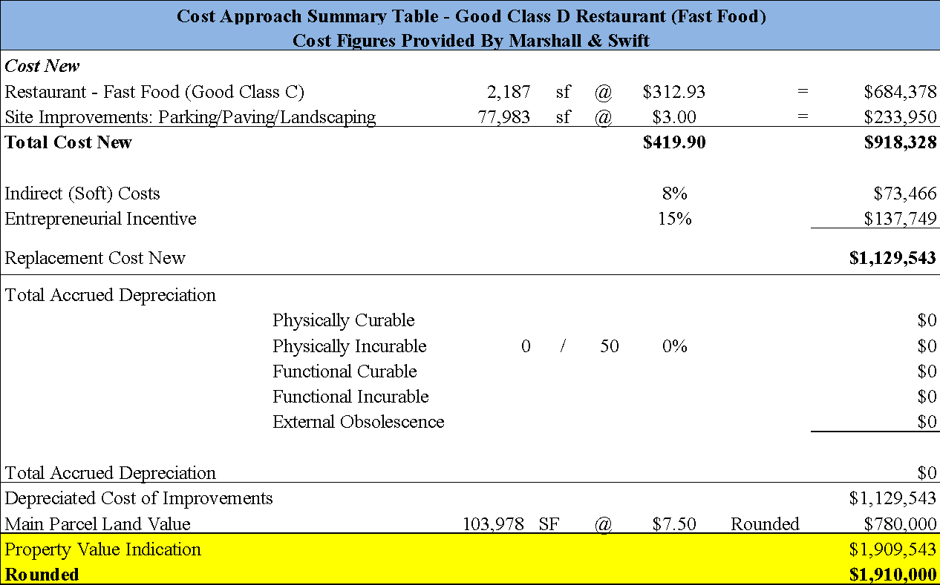

# **SALES COMPARISON APPROACH**

The Sales Comparison Approach is based on the principle of substitution, considering that a prudent investor would pay no more for a property than the cost to acquire another property of equal desirability or utility. When enough data is available the Sales Comparison Approach provides a reliable indication of value and provides insight into the actions of buyers and sellers. Valuation of the subject property by the Sales Comparison Approach utilizes the sales price per square foot of building including land.

Sales were researched for this analysis, which are documented on the following pages, followed by a location map, adjustment summary and an analysis grid. All sales have been researched through numerous sources and, when possible, verified by a party to the transaction.

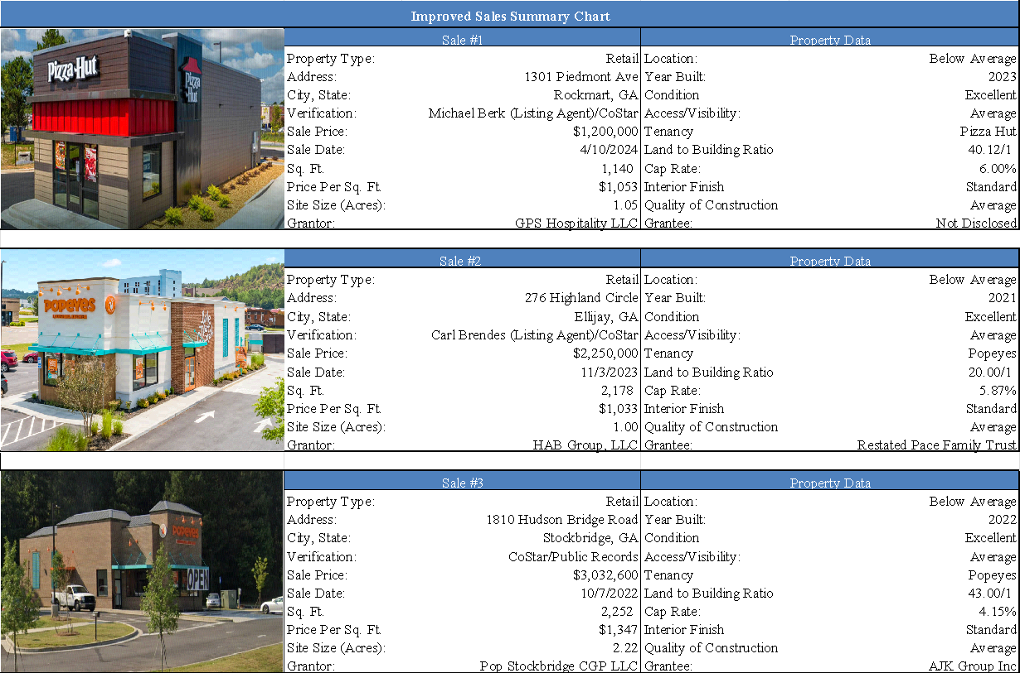

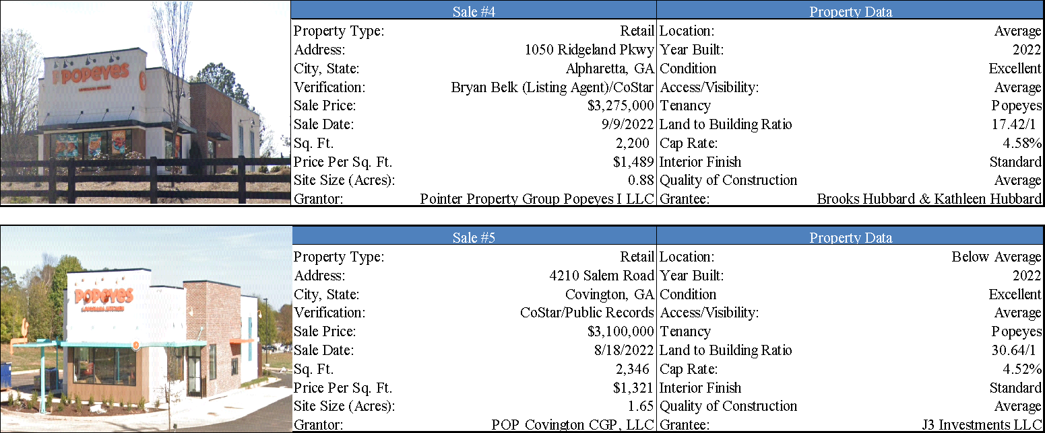

# **SALES COMPARABLE MAP**

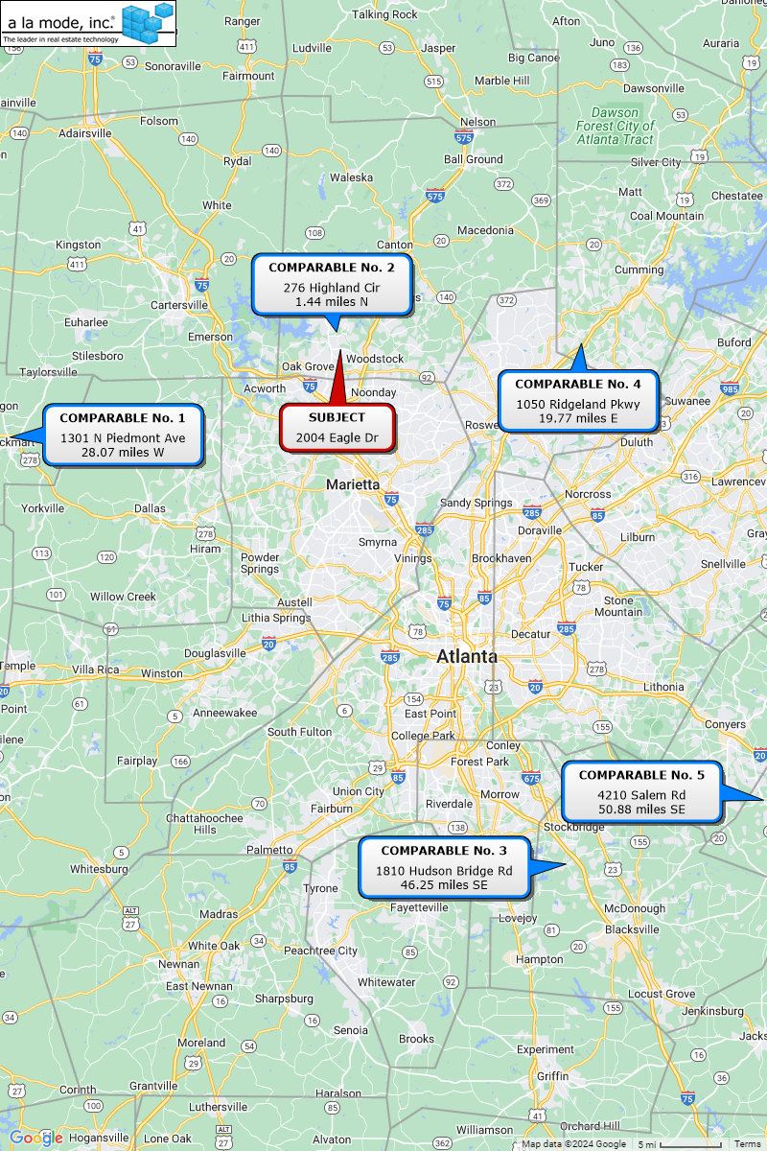

**Analysis and Discussion of Improved Sales**

The comparable sales have been analyzed and compared with the subject property. Adjustments are discussed in the summary below and shown in the sale adjustment grid that follows.

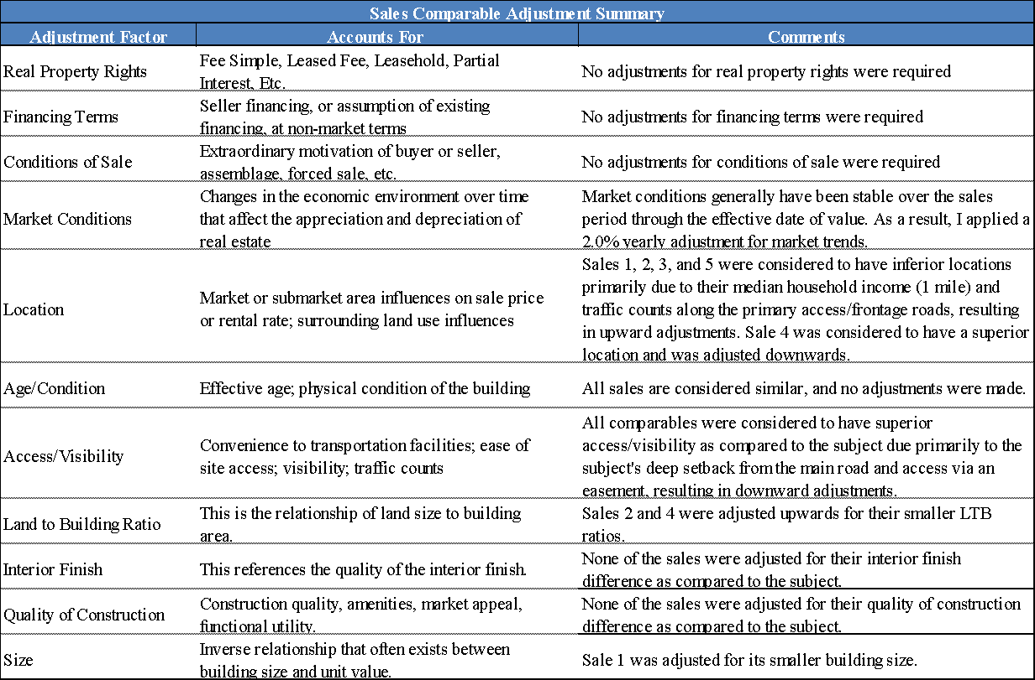

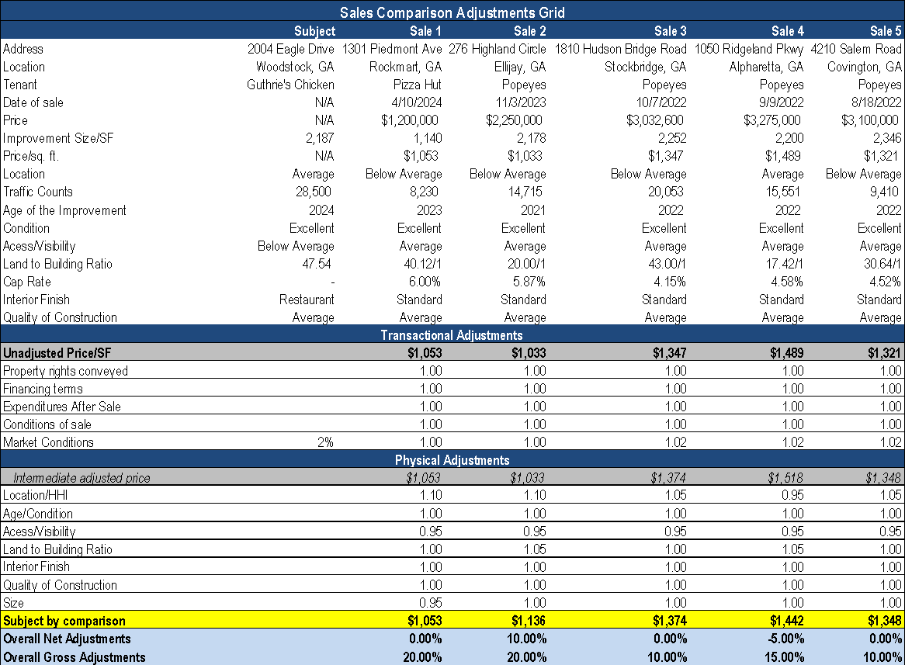

**Sales Comparison Approach Conclusion**

After adjustments, the sales ranged from $1,053 per sq. ft. to $1,442 per sq. ft., with an average of $1,271 per sq. ft. and a median of $1,348 per sq. ft. Sales 3 and 4 were considered to be the most comparable. The remaining comparables were given minimal support in arriving at our final reconciled value.

After considering the comparable building sales with respect to time, location, condition, size, building type and market demand, a sale price per square foot of $1,200 is considered reasonable and supported.

2,187 square feet x $1,200 per sq. ft. = $2,624,400

**SALES COMPARISON APPROACH:**

**MARKET VALUE AS IS (rounded) = $2,620,000**

# **INCOME APPROACH - OVERALL CAPITALIZATION**

The Income Approach is based on the principle of anticipation, considering that the value of a property may be measured by the present worth of anticipated future benefits accruing to the ownership and use of the property. The Income Approach also reflects the attitudes of investors in income properties and their requirements for returns on investments. All capitalization or discount methods are based upon the concept of time preference, which holds that future income or benefits are worth less than the same income or benefits received now, and they decrease systematically as the time for receipt is deferred into the future.

A value estimate by the Income Approach has been made which reflects current income and expense data on comparable buildings in the subject area and other areas influenced by similar economic factors.

**Occupancy and Rent Roll Discussion**

The subject property is a 2,187 sq. ft. retail restaurant building that is owner-occupied. As such, there is no in-place lease document or in-place rent-roll.

In this analysis, an annualized market rental rate will be estimated to be utilized in the Income Approach. Additionally, expense information was not provided and thus, expenses will also be applied at market terms and rates.

**Lease Structure**

Based on the market rent survey conducted on the following pages, the local marketplace typically leases similar properties on a a Triple Net (NNN) basis with the breakout of expenses as shown below:

Tenant Paid Expenses Taxes, Insurance, Repairs & Maintenance, Utilities

Landlord Paid Expenses Management, Reserves, General Administrative

**Market Rent Analysis**

To estimate market rent, we analyze comparable rentals most relevant to the subject in terms of location, date of lease, building class, size, and transaction date. Comparable rentals considered most relevant are summarized in the following table and adjustments are presented in the rent comparison adjustment grid that follows. All leases have been researched through numerous sources and, when possible, verified by a party to the transaction.

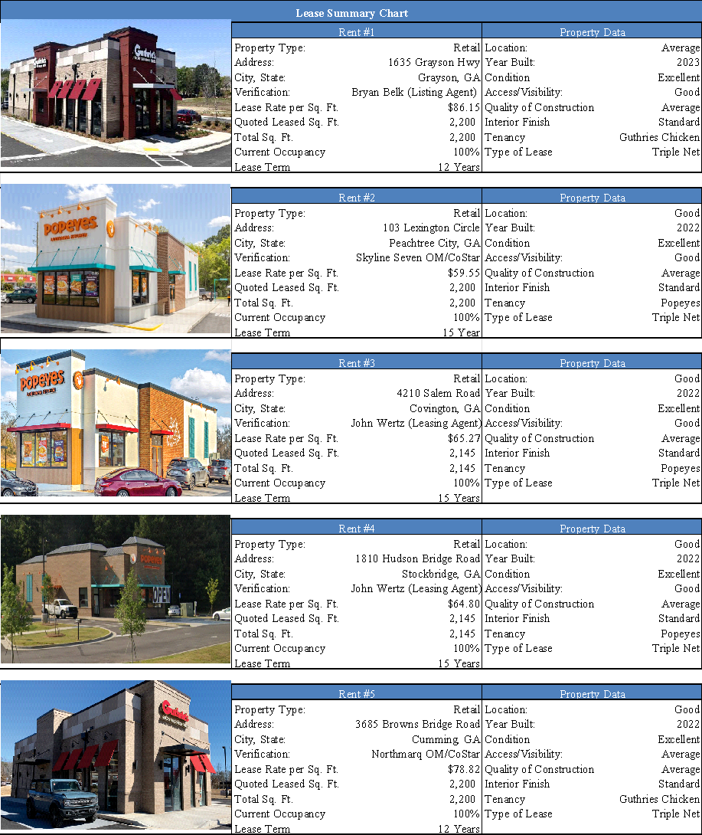

# **RENT COMPARABLE MAP**

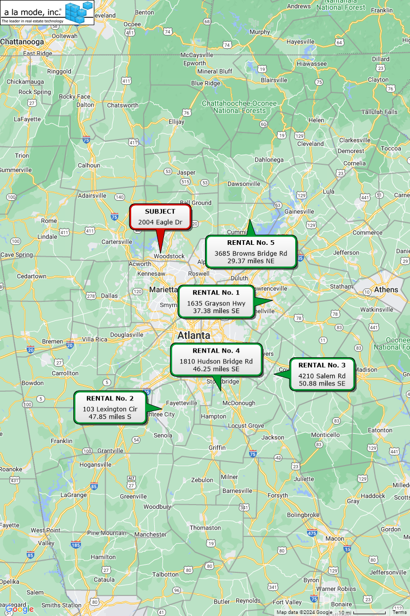

## **Analysis and Discussion of Lease Comparables**

The leases have been analyzed and compared with the subject property. Adjustments are discussed in the summary below and shown in the rent comparison adjustment grid that follows.

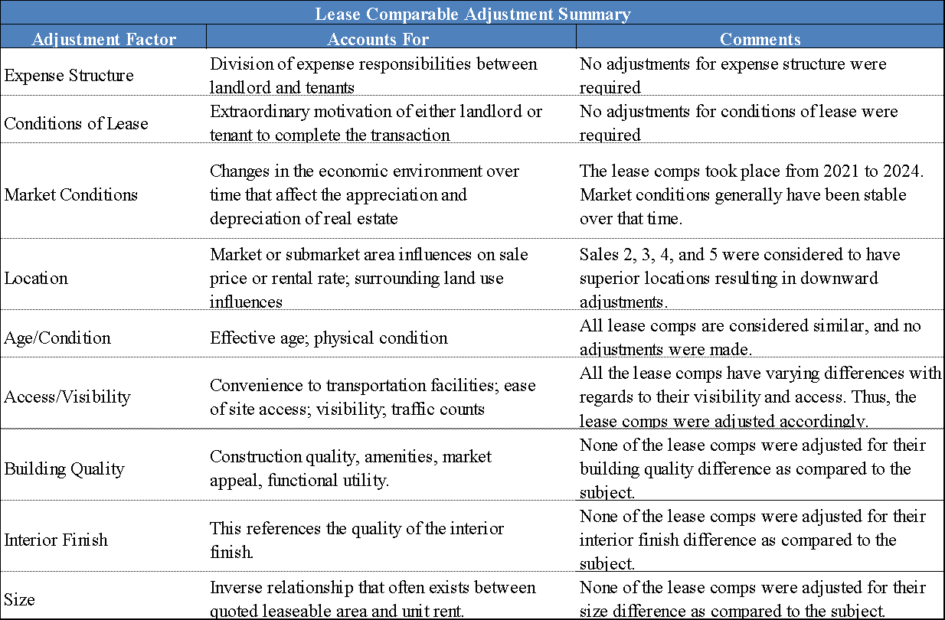

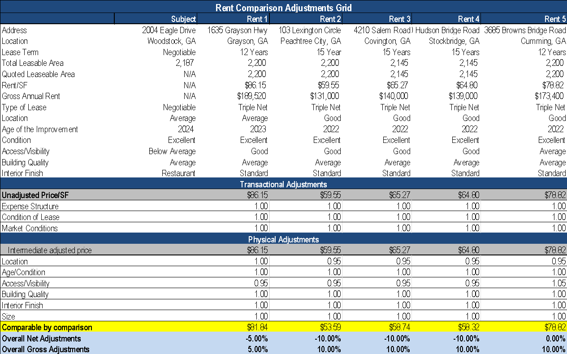

**Market Rent Conclusion**

After adjustments, the lease comparables ranged from $53.59 per sq. ft. to $81.84/sq. ft. with an average of $66.26 per sq. ft. and a median of $58.74 per sq. ft. Overall, rent comparables 1 and 3 were considered to be the most similar to the subject.

After considering all value factors with respect to location, quality of interior improvements, building characteristics and market demand, the annual average rental rate that the subject could expect to achieve is $75.00 per sq. ft. on a triple net basis.

# **POTENTIAL GROSS INCOME**

The following table summarizes the potential gross rent based on the market rents.

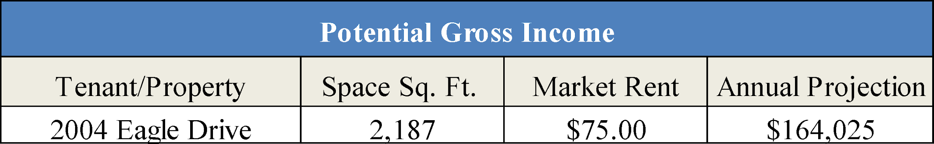

# **VACANCY AND COLLECTION LOSS**

This category accounts for vacancy as well as the time between occupants (frictional vacancy). This occupancy may vary from period to period. However, a typical investor would utilize this stabilized occupancy level within a pro forma operating statement. A provision for collection loss is typically factored in this ratio.

As seen in the marketability analysis found earlier in this report, the vacancy rate for retail properties within the Woodstock/Cherokee County retail submarket has been between 0% and 2.5% over the last few years, with an average vacancy rate of 1.6%. The market analysis also shows that the market is in a stable trend. Thus, a 5% vacancy or 95% occupancy and collection loss ratio is considered reasonable for the subject property during the economic life of the current improvements.

# **OPERATING EXPENSES**

Financial data pertaining to the subject’s operating expenses were not presented for review. In order to estimate operating expenses, the appraisers analyzed the operating statements and expenses of similar structures within the subject’s market and submarket. The appraisers also utilized average operating figures for buildings in the region based on various data sources such as broker/developer data, as well as data from the appraisers’ internal files of similar properties.

**Expense Reimbursements**

According to leases common within this market and submarket, for this property type, the tenant would be required to reimbursement the landlord for the taxes, insurance, and CAM. This will be presented in the Income Approach.

# **EXPENSE DISCUSSSION**

**Real Estate Taxes**

The subject property is taxed by Cherokee County based on an assessment made by the Cherokee County Tax Assessor. Details of the subject’s real estate taxes are discussed in the *Real Estate Tax* section of this report. This expense has been estimated at $26,507, using the concluded market value of this report with a 40% assessment ratio and the current millage rates. Due to the leasing structure, this expense will be passed through to the tenant.

**Insurance**

The appraisers reviewed the operating statements of several restaurant/retail buildings in the Cherokee County area and expenses reported by CoStar. According to the data, the subject’s proposed expense of $0.50/sq. ft. is considered to be in-line with market averages. This expense will be passed through to the tenant.

**Maintenance and Repairs**

Maintenance and repair expenses vary widely as a result of accounting techniques and procedures used by owners, and the sporadic nature of the timing of structural and mechanical failures. It is assumed that the subject’s interior will need routine maintenance and repair. Based on similar developments in the area and the subject’s age and condition, an estimated maintenance and repair expense of 1% of the effective gross income is considered reasonable and supported. Due to the leasing structure, this expense will be passed through to the tenants.

**General & Administrative**

This expense includes general and administrative expenses such as consulting expenses, miscellaneous insurance, office supplies, audit fees, subscriptions, etc., and serves as a catch all category for items not generally covered by the other expense categories. The subject is estimated to have a general administrative expense of 0.3% of effective gross income. The landlord covers this expense.

**Utilities**

This expense consists of utility costs for the unit. This expense was estimated at 3.2% of effective gross income, which is in-line with market averages. Due to the leasing structure, this expense will be passed through to the tenants.

**Management Fee**

The subject property has an estimated management expense of approximately 4% of effective gross income. This estimated percentage is reasonable considering Comparable buildings are usually managed for fees ranging from 2% to 7%. The higher fees are typically charged for large multi-tenant buildings. After considering the characteristics of the subject property, the subject’s estimated management fee of being 4% of effective gross income is considered reasonable and appropriate.

**Reserves**

Reserves cover expenses for short lived and long-term items that wear out over time, such as: water heater, roof, painting, and fixtures. Since the subject was built in 2024 and is considered to be in excellent condition, this expense is estimated to be $0.25 per sq. ft.

# **CAPITALIZATION RATE**

The capitalization rate is the factor that converts the stabilized net operating income (NOI) to a present value. It is the ratio of net income to value or sale price. In coming to an appropriate overall capitalization rate conclusion, the appraisers utilized recent market surveys from various sources, a review of Keystone appraisal files, (if available) capitalization rates derived from sales data, as well as discussions with real estate professionals from within the subject market and other competitive markets.

**Sales Comparison Approach**

The preceding Sales Comparison Approach provided capitalization rate data for all Sales. These sales provided capitalization rate data of 6.00%, 5.87%, 4.15%, 4.58%, and 4.52%, in order of newest sale to oldest. The overall average was 5.02%. These sales are supportive of our cap rate conclusion.

A capitalization rate survey conducted on retail (fast food restaurant) properties within the immediate surrounding areas of the subject over the last three years yielded a rate range of 4.1% to 6.1%. The overall median was 5.1%.

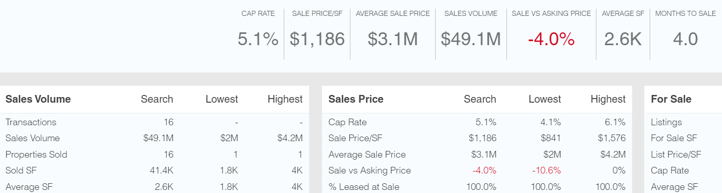

**RealtyRates.com**

According to 4Q 2023 Realty Rates Investor Survey, for Restaurant-Fast Food buildings, the capitalization rates ranged from 7.74% to 17.47% with an average of 12.09% for surveyed rates.

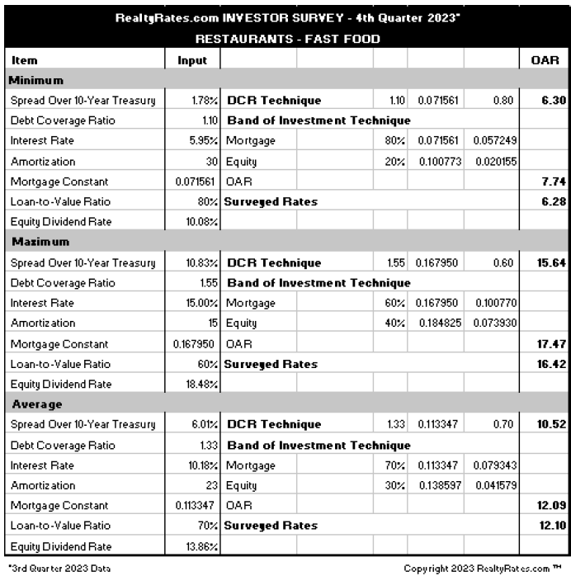

**Market Participant Interviews**

Multiple interviews were conducted with market participants familiar with retail restaurant space, particularly in Cherokee County. Market Participants have indicated that depending on term and credit of the tenant, capitalization rates range between **5.5% to 6.25%.**

**Capitalization Rate Conclusion**

Upon consideration of the various supportive data sources, as well as the subject’s location, quality of improvements, new construction, an overall capitalization rate of **5.50%** is selected for the Income Approach.

# **DIRECT CAPITALIZATION CONCLUSION**

Based on the previous analysis, the direct capitalization approach has been reconciled in the following chart.

# 

# 

# **FINAL VALUE RECONCILIATION**

The process of reconciliation involves the analysis of each approach to value. The quality of data applied, the significance of each approach as it relates to market behavior, and the defensibility of each approach are considered and weighed. Finally, each is considered separately and comparatively with each other.

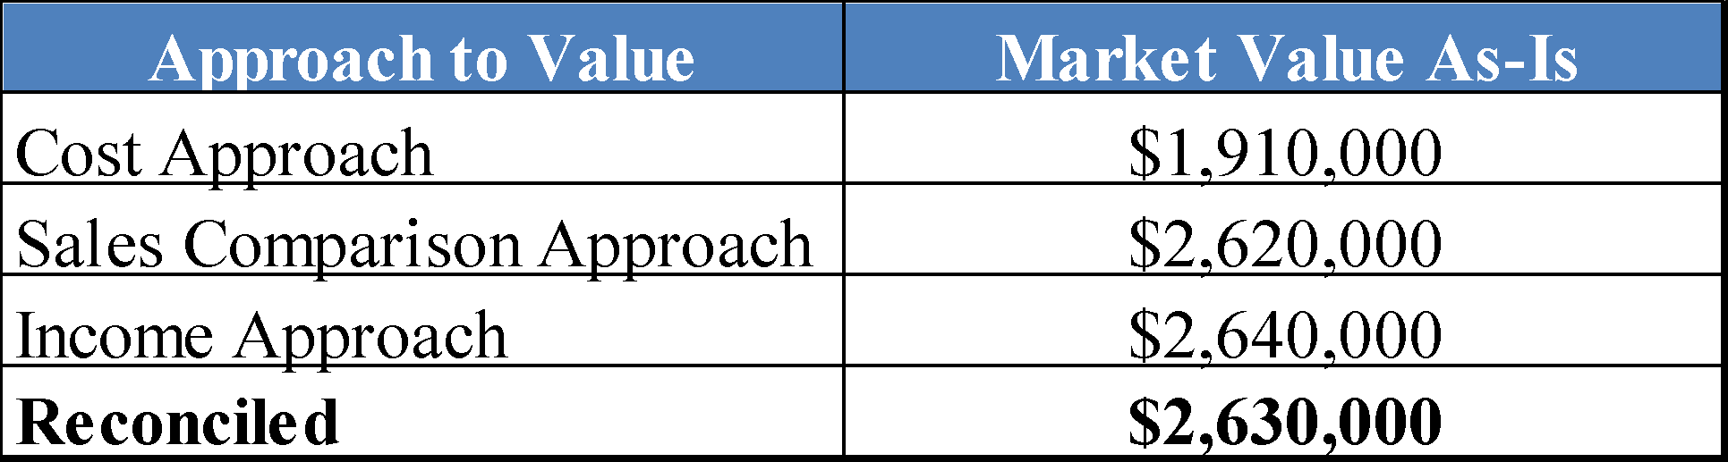

**Cost Approach**

The cost approach is most reliable for newer properties that have no significant amount of accrued depreciation. The subject represents new construction, and there is a relatively active market for land. As a result, the cost approach is applicable to the subject and is applied in our analysis. Nonetheless, it does not directly reflect market behavior, and is given secondary weight.

**Sales Comparison Approach**

The sales comparison approach is most reliable in an active market when an adequate quantity and quality of comparable sales data are available. In addition, it is typically the most relevant method for owner-user properties, because it directly considers the prices of alternative properties with similar utility for which potential buyers would be competing.

The analysis and adjustment of the sales provides a reasonably narrow range of value indications. Nonetheless, it does not directly account for the income characteristics of the subject. Therefore, this approach is given secondary weight.

**Income Approach**

The income capitalization approach is usually given greatest weight when evaluating investment properties. The value indication from the income capitalization approach is supported by market data regarding income, expenses and required rates of return.

An investor is the most likely purchaser of the appraised property, and a typical investor would place greatest reliance on the income capitalization approach. For these reasons, the income capitalization approach is given greatest weight in the conclusion of value.

**Value Conclusion**

It is our opinion that the Market Value in the Fee Simple Estate, of the 2,187 sq. ft. Restaurant building, *“As Is”* located at 2004 Eagle Dr, Woodstock, Cherokee County, Georgia, as of April 19, 2024, is:

| **TWO MILLION SIX HUNDRED AND THIRTY THOUSAND DOLLARS**  **($2,630,000)** |
| --- |

# **MARKETING PERIOD AND EXPOSURE TIME**

**Marketing Period**

The *marketing time* is an opinion of the amount of time it might take to sell a real or personal property interest at the concluded market value level during the period immediately after the effective date of an appraisal. Marketing time differs from exposure time, which is always presumed to precede the effective date of an appraisal. (Advisory Opinion 7 of the Appraisal Standards Board of The Appraisal Foundation and Statement on Appraisal Standards No. 6, “Reasonable Exposure Time in Real Property and Personal Property Market Value Opinions” address the determination of reasonable exposure and marketing time.)

There are no anticipated significant changes in market conditions in the near term. Thus, it is our opinion that a reasonable marketing period for the subject is likely to be 6 to 12 months.

**Exposure Time**

The *exposure time* is the time period assumed to have occurred prior to the date of the appraisal as required in the definition of the market value.

1. The time a property remains on the market.
2. The estimated length of time the property interest being appraised would have been offered on the market prior to the hypothetical consummation of a sale at market value on the effective date of the appraisal; a retrospective estimate based on an analysis of past events assuming a competitive and open market.

Based on our review of recent sales transactions for similar properties and our analysis of supply and demand in the local market, it is our opinion that the probable exposure time for the subject at the concluded market value / values stated previously is 6 to 12 months.

1. *The Appraisal Institute*, *Market Analysis for Real Estate*
2. *Appraisal Institute Market Analysis and Highest and Best Use*
3. *Appraisal Institute Market Analysis and Highest and Best Use*
4. *The Dictionary of Real Estate*, Sixth Edition, page 144